|  |
| --- |
| Department of Electrical Engineering and Computer Science  Case Western Reserve University |
| A Low-Cost Mobile Manipulator for Industrial and Research Applications |
| Submitted in partial fulfillment of the requirements for the degree of Master of Science |
|  |
| Edward Venator |
| August 2013 |
| Thesis Advisor Dr. Gregory Lee |

CASE WESTERN RESERVE UNIVERSITY

SCHOOL OF GRADUATE STUDIES

We hereby approve the thesis of

Edward Venator

candidate for the Master of Science degree \*.

(signed) Gregory Lee   
(chair of the committee)

Murat Cenk Cavusoglu

Roger Quinn

(date) \_\_\_\_\_\_\_\_\_\_\_\_\_\_\_\_\_\_\_\_\_\_\_

\*We also certify that written approval has been obtained for any proprietary material contained therein.

Contents

1. Introduction 1

2. Industrial Mobile Manipulation 3

3. ABBY - System Design 6

3.1 Invacare Ranger Wheelchair Base 6

3.2 ABB IRB-120 Robotic Arm 7

3.3 End Effector 8

3.4 Custom Frame Design 10

3.5 Power 13

3.6 Sensors 16

3.7 Computing Hardware 18

PC 19

National Instruments cRIO 20

ABB IRC5 21

3.8 Robot Operating System 22

The Robot Model 23

3.9 Hardware Drivers 26

4. Experimental Software 30

4.1 Mobile Base Planning 30

Localization 30

Mobile Base Trajectory Planning 37

4.2 Inverse Kinematics solver 39

4.3 Arm Navigation 42

Collision Detection 43

Kinect Data Filtering 43

4.4 Tabletop Box Manipulation 44

The Manipulation Controller 45

Box Manipulation 46

4.5 Calibration 47

4.6 QR Code Recognition and 3D Localization 48

5. Industrial Safety 52

5.1 Reflexive Speed Limiting 52

Reflexive Halt Methods for Mobile Bases 53

Reflexive Halting for Manipulators 54

5.2 Emergency Stop System 57

E-Stop Systems Used in This Lab 57

E-Stop Requirements for This Robot 58

Version 1 Prototype 59

Version 2 Design 62

6. Experimental Results 65

6.1 The Validation Task 65

6.2 Validation Results 66

6.3 Mechanical and Electrical Systems 66

Wheelchair Drivebase 66

Chassis Design 67

The ABB Arm System 68

Gripper 68

Battery Life 69

6.4 The Kinect 71

For Object Localization and Arm Planning 71

For Reading QR Codes 71

6.5 Open Source Software 72

API Stability 72

Documentation 73

Reusability of PR2 Software 73

Safety and Reliability 74

7. Conclusions and Future Work 76

7.1 Conclusions on ROS and Open Source Software 76

7.2 Future Work 76

7.3 Applications of this Robot 81

7.4 Conclusion 81

8. Bibliography 82

9. Appendix 1: Bill of Materials 85

10. Appendix 2: Localization Data 86

10.1 Ten Meter Straight Line 86

10.2 Five Laps of One Meter Radius Circle 87

Figures

[Figure 2: The electrical circuit to control the pneumatic gripper. Q1 is a 2N7000 NFET 10](#_Toc352798881)

[Figure 3: ABBY, a mobile industrial manipulator. 11](#_Toc352798882)

[Figure 4: A block diagram of the power distribution system on the robot. 14](#_Toc352798883)

[Figure 5: 13.8 volt rail dropout when compressor turns on (before addition of filter). 16](#_Toc352798884)

[Figure 6: 13.8 volt rail during compressor turn-on after addition of an LC filter. 16](#_Toc352798885)

[Figure 7: Sensors and computing hardware on ABBY 17](#_Toc352798886)

[Figure 8: The Kinect field of view 18](#_Toc352798887)

[Figure 9: The Kinect mounted to the robot 18](#_Toc352798888)

[Figure 10:ABBY’s robot model, LIDAR data (green points), and Kinect point cloud (multicolored points) visualized in Rviz 25](#_Toc352798889)

[Figure 11: The map, odometry, and base frames of the robot localization system. 37](#_Toc352798890)

[Figure 12: A histogram of successful requests from the test of the KDL inverse kinematics solver, showing the distribution of iterations required to find a solution. 41](#_Toc352798891)

[Figure 13: The box manipulation pipeline. Data from the Kinect is used to locate boxes on a table, which are then picked up and placed in the bin. 45](#_Toc352798892)

[Figure 14: QR Level 3 code (Source: Wikipedia, licensed under Creative Commons Attribution Share-Alike License) 49](#_Toc352798893)

[Figure 15: A box localized using the QR code. Red dots are the QR code finder pattern. Blue is the projected handle center. Green are the handle corners. 50](#_Toc352798894)

[Figure 16: A design for an emergency stop remote. 59](#_Toc352798895)

[Figure 17: A design for an emergency stop receiver and aggregator. 60](#_Toc352798896)

[Figure 18: Revised emergency stop remote ciruit. 62](#_Toc352798897)

[Figure 19: Revised emergency stop receiver/aggregator circuit. 63](#_Toc352798898)

[Figure 20: Voltage curve during discharge test with actuators idle. 70](#_Toc352798899)

[Figure 21: Voltage curve during discharge test with drivetrain exercised. 70](#_Toc352798900)

Abstract

This thesis describes the creation of a mobile robot equipped with an industrial robotic manipulator. The goals of this project were to minimize cost and development time by using commercially-available hardware and open source software. The resulting mobile manipulator incorporates a suite of commercially-available sensors and processing hardware to enable the robot to operate as an intelligent agent alongside humans. Ultimately, this robot will be employed in research on autonomous kitting in industrial environments.

# Introduction

Robots have been an important part of the manufacturing industry for many years. Industrial manipulators are used for tasks such as painting, welding, and assembly. Automated vehicles in industry are used to deliver pallets and other goods through factories and warehouse. However, the combination of these technologies, the mobile manipulator, has yet to see adoption in industry. In academia, researchers have done extensive work toward developing mobile robots, including mobile manipulators. These robots are increasingly capable, demonstrating advanced perception, navigation, and manipulation, as well as a facility for numerous everyday tasks. However, these mobile manipulators have yet to make the jump to industry.

Manufacturers have yet to adopt mobile manipulation robots in spite of the fact that a mobile manipulator has many uses in manufacturing. Mobile manipulators can perform the same tasks as existing industrial manipulators on assembly lines, but their mobility allows the manufacturing cell to be rapidly reconfigured, just as human workers can be easily reallocated as manufacturing demand changes. In addition, a mobile manipulator can build upon the capabilities of automated vehicles in a factory setting. Whereas automated vehicles must still be loaded and unloaded by human workers, a mobile manipulator can function entirely on its own without human assistance. Conversely, recent advances in robotics allow for closer collaboration than ever before between man and machine. Whereas most industrial robots operate in guarded manufacturing cells, developments in sensing and planning technologies allow robots to operate safely without guards. This opens the door to a mobile industrial robot that can work with human workers as an assistant, rather than a machine.

One of the remaining un-automated tasks in many factory environments is kitting, the task of collecting the components of an assembly from a factory's inventory. Currently, this task is performed by human pickers, sometimes with the aid of vehicles or moving inventory systems. In order for a robot to be able to perform this task, it must be able to navigate a factory environment, recognize and manipulate a variety of objects, and interact with human workers. These requirements add up to the need for a mobile industrial manipulator with modern perception and planning software.

Some of the reasons that the manufacturing industry has failed to adopt mobile manipulation robots are cost, reliability, and safety. This project primarily addresses the first of these issues (cost), but begins to explore the second two. The main goal of the project was to construct a mobile manipulator at low cost using as many off-the-shelf, mass produced components as possible The resulting platform is a mobile robot named ABBY. At a total estimated cost of under $40,000 (See Appendix 1: Bill of Materials), ABBY is competitively priced with many stationary industrial manipulators. Furthermore, because ABBY’s components are commercially available, they have been individually tested and are mass-produced.

The resulting platform demonstrates simple mobility, manipulation, perception, and planning abilities. In addition, the reliability and usability of open source robotics software was explored. Several avenues for further research and improvement of the platform were identified for future researchers to address.

# Industrial Mobile Manipulation

Mobile industrial robot development began decades ago with the first Automated Guided Vehicles (AGVs). Early AGVs were unintelligent vehicles employed to move loads in factories following paths that were marked with wires buried in the factory floor. These vehicles were only practical for permanent installations in unchanging environments; “reprogramming” a first generation AGV required that the path be removed from the floor and reinstalled [1].

More modern AGVs have eschewed physically-marked paths in favor of virtually-defined paths. The AGV uses sensor systems to localize itself in the factory and navigation software to follow paths, which can be statically defined or dynamically chosen by a higher-level planner. The higher level planner chooses paths for an AGV from amongst a graph of paths through the factory or warehouse. A single high-level planner may coordinate multiple AGVs to prevent traffic jams and allocate tasks [2]. Although these modern AGV systems are more flexible than their predecessors, they still depend on an ordered factory or warehouse environment, and are not designed to cooperate with human workers. They execute pre-programmed routines to move loads between loading docks.

Implementing such a system requires that all of the possible paths for the AGVs be predefined, which makes commissioning such a system a lengthy and labor-intensive process. Predefining all of the paths for an AGV may not be practical if the inventory system is large and does not have readily-defined nodes such as loading docks. These systems are useful for tasks such as pallet transportation, and many such systems are fork lifts [3]. However, AGVs are inflexible; they cannot adapt to changing inventory organization, changing assembly line configurations, or changes in their environment. An obstacle placed along an AGV path could disable an entire AGV system by creating a bottleneck or blockage.

At least one company, Kiva Systems, has moved from the AGV paradigm to a smart-warehouse system[4]. In this type of system, all of the inventory is stored on pallet-like mobile shelves, and a group of mobile drive units rearrange and deliver the shelves as necessary to bring items to assembly and packing stations. Kiva robots cannot manipulate individual items, so the task of loading and unloading the shelves is left to human pickers, and the robots are used purely as mobile bases for the shelves. This system is an evolution from the traditional AGV in that there are no pre-planned paths; instead, the mobile robots are entirely free to move through the warehouse environment. This system also has some advantages over AGV systems that stem from the entire inventory being movable. Namely, the warehouse is constantly being reorganized as it is used. This allows the inventory management system to optimize the inventory, moving items around to make commonly-needed items more accessible and improve the speed of the overall system[5]. Although the Kiva system does not require that paths be prelaid or preplanned, it does require that a warehouse be specifically designed for and used exclusively by its robots. The system cannot be used with existing inventory shelves, only with the movable shelves designed for its robots. It also requires that the inventory environment be outfitted with a grid of barcodes on the floor to facilitate localization.

Mobile manipulators have made little headway into industry, partly because of the rarity and cost of mobile manipulators[6]. However, researchers have been exploring the application of mobile manipulators in industrial settings for several years. In 2004, a group at the University of Verona, Italy devised a mobile manipulator for the pharmaceutical industry[7]. This robot consisted of a custom-made 5 DOF manipulator with one passive DOF mounted on top of a commercially-available mobile base. The system used a vacuum gripper to pick up cardboard boxes from pallets and put them on shelves. This system was capable of navigating freely through a partially structured dynamic environment using a local and global planner. The resulting robot is functionally similar to ABBY, but was to be used for the task of loading items from pallets into an inventory shelving system, whereas ABBY’s purpose is to pick from inventory and deliver items to assembly stations. More recently, in 2011 a group at the Intelligent Systems and Production Engineering Research Center for Information Technology in Karlsruhe, Germany developed a bimanual manipulator using a custom drive base and two KUKA Lightweight Robot arms[8]. It used a Microsoft Kinect, two high resolution cameras, and three LIDAR scanners for perception as well as force feedback in its manipulators. This platform was exceptionally capable, but was designed more as a general-purpose mobile manipulator than as an industrial robot. This platform’s price was not listed, but affordability was not a goal of the project. The main focus of the research was on the development of a software platform for mobile manipulation and on developing new planning methods for the robot’s manipulators.

# ABBY - System Design

ABBY’s design was dictated by several factors. The primary factor in the design was reduction of cost, which was achieved by using materials and components already available in Case Western Reserve University’s Mobile Robotics Lab.



Figure 1: An annotated rendering of the robot showing several major components.

## Invacare Ranger Wheelchair Base

The Invacare Ranger is a wheelchair chassis in Invacare’s Storm series. The wheelchair base has a differential drive system with two pneumatic drive wheels in the back and two solid caster wheels in the front. The drive wheels are each powered by a 24 volt DC motor geared for a maximum speed of 5 miles per hour (2.24 m/sec)[9]. Because of the configuration of the robot’s wheels, it can spin on its own axis and drive forward and backward. It cannot move sideways.

The wheelchair base is prone to wheel slip when commanded to accelerate or decelerate quickly. The acceleration limits of the robot were characterized by testing a series of constant linear acceleration commands. These tests were performed with the robot’s arm in the stowed position on a smooth tile floor. From these tests, the maximum achievable forward acceleration (with no slip) was determined to be about .1 m/sec2. The same test was performed using constant rotational accelerations. From these tests, the maximum rotational acceleration was determined to be about 0.1 rad/sec2.

A Sabertooth 2x50 dual brushed DC motor controller controls the speed of the motors in the mobile base. The Sabertooth 2x50 is an H-bridge PWM motor controller that supplies a variable DC voltage from -24 volts to +24 volts to each motor based on commands it receives over a serial data connection. The Sabertooth 2x50 is powered by a 24 volt DC rail that is energized and de-energized by the emergency stop circuit described below in .

## ABB IRB-120 Robotic Arm

The manipulator on the robot is an ABB IRB-120 industrial robotic arm. The IRB-120 is a six-axis robotic arm with a spherical wrist. It has a tool flange that allows for the mounting of end effectors as well as pneumatic and electrical connections near the tool flange to connect sensors and actuators to the arm. The IRB-120 is ABB’s smallest robotic arm, with a 580 mm reach and a payload capacity of 3 kg. The arm itself weighs 25 kg and must be mounted to the extreme front of the robot, which means its weight exerts a large moment on the robot. This was a serious consideration in the placement of the robot’s center of mass. It can be mounted at any angle, and on this robot is mounted at 90° (with the base mounted to a vertical surface). The arm is mounted vertically on the front of the robot so that the majority of the arm’s work envelope is outside of the volume of the robot. This maximizes the functional work envelope of the arm and minimizes the possibility of the arm colliding with other parts of the robot. However, this mounting orientation does somewhat hamper the arm’s ability to lift objects from horizontal surfaces.

The IRB-120’s joints are powered by non-back-drivable AC electric servos, with position feedback from resolvers. According to ABB, the IRB-120 is capable of position repeatability of 10 micrometers. The arm’s position is controlled by an ABB IRC5 Compact robot controller, which is in turn commanded by a ROS Industrial interface. The details of this control structure are described later in this document.

## End Effector

There are many types of grippers and graspers used with industrial robots. Some are purpose-built fixtures for holding specific parts. Some grippers use suction to be able to quickly pick up light objects such as electronic components. Still other graspers use dexterous fingers to be able to securely pick up and manipulate objects of different shapes and sizes. This robot uses one of the simplest gripper types, a two-position parallel plate gripper.

The gripper was primarily chosen based on cost and availability. A dexterous grasper like the BarrettHand costs about $30k, which would nearly double the cost of this robot. The pneumatically-actuated parallel plate gripper has only two positions (open and closed), and is simply and cheaply constructed from aluminum and a single double-throw pneumatic piston. When open, the gap between the jaws is 65 millimeters, and when closed the gap is 46 millimeters.

The gripper is pneumatically actuated using stored air from accumulator tanks that are kept at 825 kPa by an onboard compressor. The compressor is turned on and off by an Innovation First Spike relay, which is controlled by digital pressure switch calibrated to close at 690 kPa and open at 825 kPa. This control circuit can be seen in the power distribution diagram in Figure 4. This 825 kPa stored air is regulated down to 275 kPa working pressure and used to actuate the gripper. The pneumatic piston in the gripper is controlled by a pneumatic solenoid valve, a magnetically actuated valve with one pressure inlet and two pressure outlets. The inlet is connected to the output of the regulator and the outlets are connected to each of the inlets on the gripper’s pneumatic piston so that applying pressure through one outlet opens the gripper and applying pressure through the other outlet closes the gripper. The solenoid valve is designed to that when one outlet is connected to the pneumatic pressure inlet, the other is vented to the atmosphere. The valve is actuated by running current through one of two solenoid coils. This current is supplied by a custom circuit based on an Arduino microprocessor development kit, as shown in Figure 2.

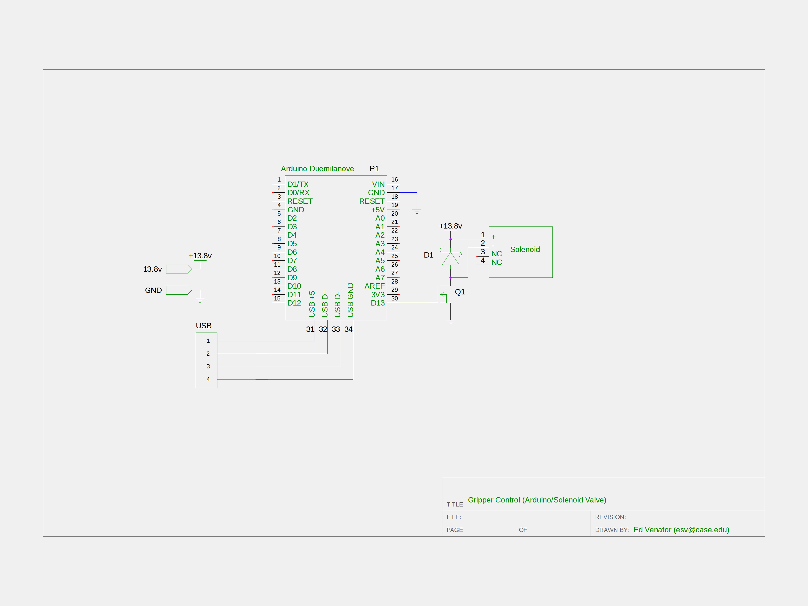

Figure 2: The electrical circuit to control the pneumatic gripper. Q1 is a 2N7000 NFET

Although the gripper has only two positions, the pneumatic nature of the system makes the gripper jaws back-drivable, with a constant gripping force proportional to the working pressure of the pneumatic system, which was set by the pneumatic system’s adjustable regulator to 275 kPa. The regulator can be set to any pressure up to the system’s maximum pressure of 825 kPa. The regulator setting was chosen so that the gripping force would be great enough to ensure a strong grasp on manipulated objects without being so great as to damage them.

## Custom Frame Design

Coupling together the ABB IRB-120 robotic arm and the Invacare Ranger wheelchair base is the main frame of the robot. The structural elements of the frame are made from Bosch Rexroth aluminum profile struts. This Bosch rail was chosen because it was readily available in the lab, but it has several features that make it a good choice for a prototype robot. Bosch rail is an extruded aluminum product with T-slots running the length of the rail. Because T-slots do not require holes to be drilled in the rail for mounting, they allow flexibility in adjusting mounting positions on the prototype robot. However, the downside of this is that heavy objects mounted to vertical rails, such as the arm, may slip if the bolts are not very tight. Because Bosch rail is aluminum, it is easy to machine, but strong and relatively light.



Figure 3: ABBY, a mobile industrial manipulator.

The design of the frame itself was motivated by the need to hold the IRC5 Compact robot controller and the assorted power and control electronics of the robot. The IRC5 is large (480mm x 580mm x 258mm) and heavy (28.5kg), and it dominates the robot frame. Previous experience with Invacare Storm Series chassis showed that they were prone to tipping unless the center of mass was carefully placed, so robot frame was meticulously designed in 3D CAD software to place the center of mass as close to the center of the robot volume as possible. The mass of every component of the robot was entered into the CAD models, and components were placed so as to keep the center of mass low as well as relatively centered between the front and rear wheels. The final center of mass, as determined by the CAD model, is 0.2 meters in front of the rear wheels (0.48 meters behind the front wheels) and 0.494 meters from the ground. The robot's estimated weight is 195 kg.

In addition to the Bosch rail structural elements, the frame includes four panels for mounting the robot’s electronic and pneumatic components. It was important to protect the onboard electronics from damage in the case of a collision, so the majority of the electronics are mounted to a polycarbonate panel underneath the IRC5, where they are completely enclosed inside the robot. The advantage of this choice is that these electronics are safe from collisions, and the mass of the heavy power electronics is kept low to the ground. Although this design is advantageous in terms of keeping the robot’s overall volume small and the robot’s center of mass low, it is not user-friendly in the event that the robot requires service. Fortunately, now that the robot is complete, it has proven very reliable and rarely requires service. The top panel of the robot, also made of polycarbonate, holds the pneumatic system and the PC. These were mounted on the top panel in anticipation that they would require more user access and to put the pneumatics close to the arm. Two front panels, made of aluminum sheet, hold the main power distribution rail and the power supply for the LIDAR. The power distribution rail is mounted on a front panel to make it easily accessible, and the LIDAR power supply is mounted on a front panel to place it close to the LIDAR, which is mounted to the front frame rail.

On the front of the frame is a vertical mast made of Bosch rail. This mast serves several purposes. First and foremost, it provides a mounting point for the IRB-120 robotic arm. The rails are spaced so that the arm’s four mounting holes line up with the two rails, and the arm can be fixed to any position along the height of the rail by tightening the T nuts that hold it in place. This allows the robot to be reconfigured for different tasks that may require the arm to be mounted at different heights. In addition to holding the arm, the mast provides a high vantage point for a Kinect camera and allows the WiFi router to be mounted far away from possible interference from other electronics.

## Power



Figure 4: A block diagram of the power distribution system on the robot.

All of the robot’s power is distributed using DIN rail power distribution blocks. These blocks are modular, insulated, and compact. The robot has two DC voltage buses (24 volt DC, and 13.8 volt DC) and a single ground block.. In addition to these main voltage buses, several parts of the robot have their own power regulators and supplies.

The robot’s main voltage rail is a 24 volt DC bus supplied by two 12 volt batteries in series. This 24 volt bus is required by the Invacare wheelchair base’s drive system, and the Invacare wheelchair base includes the batteries that supply the bus. The batteries are connected in series with a 120 amp resettable circuit breaker, which also serves as the main power switch for the robot. In addition to the robot’s drivetrain, the robot’s PC, LIDAR, and the National Instruments cRIO are all powered directly from the 24 volt DC bus.

Because the cRIO is a critical component of the drivetrain and the inductive kick of the motors can cause significant noise on the 24 volt DC bus, a peak-detector circuit is used to protect the cRIO from voltage droop on the 24 volt rail.

In addition to the two DC buses on the robot, there is an AC inverter, which is used to power the ABB IRC5 Compact robot controller. The IRC5 requires 220 volt AC at 50 Hz. The inverter on the robot is capable of delivering up to 2 kW of power continuously and surges of up to 3kW, which is necessary to account for the high current draw when the controller first enables the motor drive. The inverter is powered from the 24 volt DC bus and is only used to power the IRC5 Compact and (through the IRC5) the IRB-120 robotic arm.

Much of the electronics on the robot require a lower voltage bus to operate, nominally 12 volts DC. These electronics are powered by a Samlex America SDC-15, a 13.8 volt switchmode step-down regulator that can supply up to 12 amps[10], which is powered from the main 24 volt bus. This bus powers the WiFi router, emergency stop circuitry, the cRIO interface board, the Kinect camera, and the pneumatic compressor.

Because the compressor draws a large amount of current, the 13.8 volt regulator's output would droop to about 5 volts for approximately 450 ms (see Figure 5) when the compressor switched on. This droop was sufficient to cause the onboard Ethernet router to reboot, interrupting communications between the computers onboard. In order to prevent this problem, an LC filter was added to the 13.8 volt power rail. A 50mF capacitor acts as a charge reservoir for the electronics on the 13.8 volt power rail (including the router), and a 55 μH inductor acts as a current choke to limit the instantaneous current draw when the compressor turns on. Figure 6 shows that this filter kept the 13.8 volt rail from dropping below 10 volts, and it recovers to its nominal voltage in under 100 ms. This droop is not enough to cause the router to reboot.

|  |  |
| --- | --- |
| Figure 5: 13.8 volt rail dropout when compressor turns on (before addition of filter). | Figure 6: 13.8 volt rail during compressor turn-on after addition of an LC filter. |

In order to monitor the state of the voltage rails, each one is connected to an analog to digital converter (ADC) on the National Instruments Compact RIO that controls the drive base (see below). The ADC monitors the main 24 volt bus, the 13.8 volt bus, the power supply to the cRIO (which is protected from rail droop by a peak detector, as shown in Figure 4), and the rail that powers the drive base, which is switched on and off by the emergency stop circuit.

## Sensors

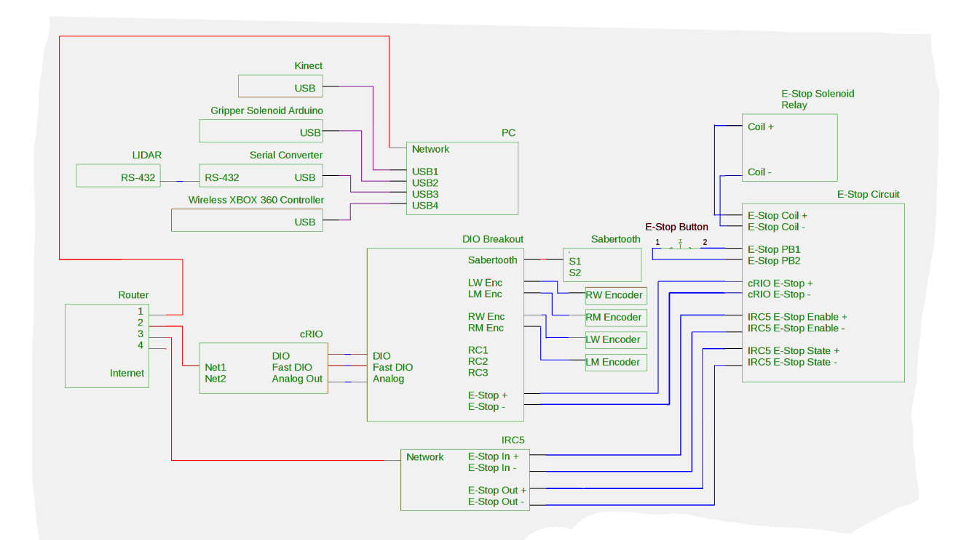

Figure 7: Sensors and computing hardware on ABBY

In order to sense the motor speed, there is a Grayhill 61R-256 encoder on each motor’s output shaft. The encoder outputs quadrature pulses at a frequency proportional to the motor speed. These motor shaft encoders have very high resolution output (256 pulses per revolution), but cannot provide accurate wheel position information for odometry because of backlash in the gearboxes. For odometry, there is an encoder attached to each wheel by a toothed belt. The wheel encoders spin sixteen times more slowly than the motor encoders, but still provide a very high resolution output (0.7 mm per encoder tick). The output of the wheel encoders is differentiated to get the wheel velocities, which are then fed as control inputs into a Kalman filter that outputs a robot pose estimate consisting of X and Y coordinates and a heading.

|  |  |
| --- | --- |
| kinect_fov.png  Figure 8: The Kinect field of view | IMG_20121110_164247.jpg  Figure 9: The Kinect mounted to the robot |

The Microsoft Kinect is an RGBD (Red, Green, Blue, Depth) camera marketed as a gaming controller. ABBY has a Kinect camera mounted high on the front mast with a custom-designed acrylic bracket that fixes is at a down-ward looking angle of 51 degrees from the horizontal. At this angle, the Kinect is looking down into the IRB-120's work envelope and capable of viewing the floor in front of the robot. The RGBD data from the Kinect are converted into three-dimensional point clouds, which are used to detect obstacles and manipulable objects.

An LMS-291 laser ranging sensor (LIDAR) from SICK AG of Waldkirch, Germany is mounted horizontally to the front of the robot. The LIDAR provides planar range scans of a 180 degree arc in front of the robot. These range data are used for localization and obstacle detection.

## Computing Hardware

The robot has three main computing devices on board, connected by a local Ethernet network with an onboard WiFi access point so operators can wireless connect to the robot for maintenance and control.

### PC

The majority of the robot’s processing is performed on a Linux PC. This PC runs all of the perception and higher level planning algorithms, which do not require a real-time operating system. In addition, the PC is responsible for processing LIDAR and Kinect data directly from the sensors. These tasks are computationally intensive, particularly the tasks of filtering the robot’s links out of the Kinect point cloud and maintaining a collision map.

The computer was specified so as to balance cost, physical size, and processing power. The computer’s motherboard is an ASUS micro-ATX motherboard, which was chosen over the smaller mini-ITX form factor because many mini-ITX boards were found to have poor thermal management during the construction of the autonomous wheelchair OTTO. The case chosen was the smallest micro-ATX case available from major computer vendors, measuring 0.33m x 0.10 m x 0.39 m. The case came equipped with a compact AC power supply, but this was replaced with a 24 volt DC power supply so that the robot would not need a second inverter to supply 115 volts AC. The computer case and power supply combined cost $155, with the majority of the cost ($90) going toward the DC power supply.

The PC’s processor is an Intel i5 2500k, a four-core processor utilizing Intel’s Sandy Bridge architecture clocked at 3.2 GHz. The PC also has 8 gigabytes of DDR3 RAM and a solid state hard drive, which would have cost about $50. The motherboard, processor, and RAM were purchased specifically for this robot at a cost of $342. Combined, the total cost of the PC for the robot was about $550. This cost is consistent with the goal of producing a low-cost mobile manipulation platform, and will continue to drop as computer processers become cheaper and more powerful.

### National Instruments cRIO

Some tasks pertaining to sensor interfacing and motor control require real-time processing, analog to digital conversion, and robust digital I/O. These tasks are beyond the reach of commercially-available PC hardware. The cRIO 9072 from National Instruments combines a 266 MHz PowerPC processor with a 1M gate Xilinx FPGA. The PowerPC processor is running the vxWorks real-time operating system and the Xilinix FPGA is connected to the PowerPC processor and to 8 reconfigurable IO slots. These reconfigurable IO slots accept a myriad of modules sold by National Instruments ranging from analog to digital converters to serial bus interfaces. ABBY’s cRIO is equipped with three IO modules. A digital input/output module is used to read values from the wheel encoders and to output the enable signal to the emergency stop. A high speed digital input/output module is used to read values from the motor encoders and to send serial packets to the Sabertooth motor controller. An analog input module is used to monitor the voltage rails and read values from the yaw rate sensor.

The FPGA is used to perform minimal signal processing on the inputs and outputs, including counting encoder ticks and forming packets to command motor speeds. Besides this signal conditioning, the only processing performed on the FPGA is the PID controller that determines the motor speeds. Because PID control is dependent on very fast loop closure (10 ms) and is sensitive to the lag that can occur even in a real-time operating system, it is implemented on the FPGA. In addition to this minimal processing, the FPGA acts as a bridge between the IO connections and the cRIO’s PowerPC processor.

In addition to the FPGA, the robot uses the cRIO’s PowerPC processor for low-level processing related to the operation and control of the drive base. The robot’s physical state observer (PSO) takes in the current encoder counts and yaw rate sensor measurements from the FGPA and uses a Kalman filter to generate an estimate of the robot’s current position. The PSO used on this robot is described in detail in [11]. In addition to this processing, the PowerPC operating system passes raw values from the FPGA to the robot’s PC over the robot’s local Ethernet network and receives speed commands from the robot’s PC that it then passes to the PID controller on the FPGA.

### ABB IRC5

The ABB IRB-120 robotic arm is controlled by ABB’s IRC5 Compact robot controller. This controller contains all of the processing hardware and power electronics to control the arm. It runs a proprietary real-time operating system that must be programmed in ABB’s RAPID programming language. Although the IRC5 has built-in software to perform inverse kinematics and path planning, the preferred method of programming it is to “teach” it by manually moving the robot to points. Although this method is useful in industrial environments where the robot executes a predefined path, it is not compatible with a dynamic planner. Because of these limitations of the RAPID programming language and operating system, the software on the controller performs the bare minimum to interface with the IRB-120 arm. There are two TCP servers running on the controller. One publishes the current state of the arm, including joint states and stop conditions, and the other receives joint trajectories as a stream of joint angles. Each point in the trajectory contains six angles, which fully specifies the position of the robot. The only processing that the IRC5 performs is interpolation between the points in the trajectory, which is accomplished with the built-in functions of the RAPID programming language.

## Robot Operating System

The robot’s software runs within Robot Operating System (ROS). ROS is a framework for research robotics development that encapsulates algorithms as nodes, which pass information to each other through sockets as messages. The use of modular nodes makes it easy to add functionality to the robot without adding complexity. Standardization of messages within ROS makes it easy to swap nodes for other nodes that perform similar functions. ROS also has a vast library of existing nodes and algorithms, allowing researchers to leverage prior work without having to reimplement algorithms.

ROS nodes communicate to each other by sending messages to each other on topics. Messages have predefined types that define the fields of the message. Many message types are already defined in the ROS core and in existing ROS packages, but developers can also define their own message types. Topics are identified by names, which are organized into hierarchical namespaces. ROS nodes can publish messages to one or more topics for other nodes to subscribe to. Many ROS nodes may publish to a single topic, provided that all the message types are consistent, and many ROS nodes can subscribe to a topic. ROS topic communication is distributed, meaning that nodes communicate directly from the publisher to the subscriber, and the ROS master node only facilitates this communication by maintaining a list published topics and negotiating the direct connections between nodes[12].

In addition to one-way communication through ROS topics, ROS nodes can provide services to one another. A service is defined by a request message and a response message. A ROS node providing a service advertises it by its name in a hierarchical namespace, similar to the topic naming system. A service client sends a request message to the service server containing parameters or data to be processed. The service server performs the service requested and sends a reply message containing processed data or a status message about the service[12].

ROS also provides an action server interface. Like ROS services, ROS actions are based on a server-client model. Whereas services are synchronous—the client blocks until it receives a reply—actions are asynchronous, making them more appropriate for requests that make take a long time, such as moving an actuator or querying a sensor. Actions consist of three messages. The client sends a goal message to the action server. The server acknowledges the goal and begins processing it. Optionally, the server may publish feedback messages while it is processing the goal. When the server is finished processing the goal, it sends a result message, which notifies the client that it has finished processing the goal and returns the result of the process[13].

### The Robot Model

Another feature of ROS is the definition of robot physical characteristics for visualization and simulation using Universal Robot Descriptor Files (URDF). URDFs incorporate kinematic information such as joint geometry, inertial properties, collision information defined by geometric primitives or meshes, and visualization rendering information, also defined by geometric primitives or meshes. URDFs are a dialect of XML, with tags defined for robot links and joints. Various ROS nodes use the data parsed from URDFs for tasks such as kinematics and frame transforms, collision detection, physics Simulation, and visualization in the Rviz GUI application. ABBY is fully defined in a modular URDF file generated using the ROS xacro system of xml generation macros.

The robot frame is defined in the URDF as a series of links joined by fixed joints. The visual, collision, and inertial data for each of the links was imported from a 3d model of the robot created in Autodesk Inventor, a 3D CAD package. The only movable joints on the main robot frame are the wheels and casters, which can spin freely. When the robot is running, a static joint state publisher publishes a constant angle of 0 radians to all of these joints, but these joints could be used in the future for tasks such as modeling the current position of the casters if the necessary sensors (joint position encoders on the casters) are added.

The Kinect and the SICK LIDAR are defined as xacro macros that place their visualization and collisions meshes in the URDF and define all of the necessary sensor frames as mass-less links. This makes it easy to reuse the sensors in models of this and other robots by simply importing the xacro macros. The macros each define a sensor root link at an externally visible point on the sensor body. This is much easier than the previous method of manually publishing a transform from the robot root link to the sensor frame because the sensor frame is located inside the body of the sensor and consequently difficult to locate on the physical robot.

The IRB-120 arm is also defined as a xacro macro. Each of the 7 links is defined by a visualization/collision mesh created from solid models of the arm obtained from ABB. These links are joined by six joints, which are defined according to the joint dimensions and rotation limits provided in ABB documentation. This definition of the arm is used by the forward and inverse kinematics solvers to convert joint angles into Cartesian coordinates and vice versa. It was also used to generate the arm navigation package that performs trajectory planning for the arm.

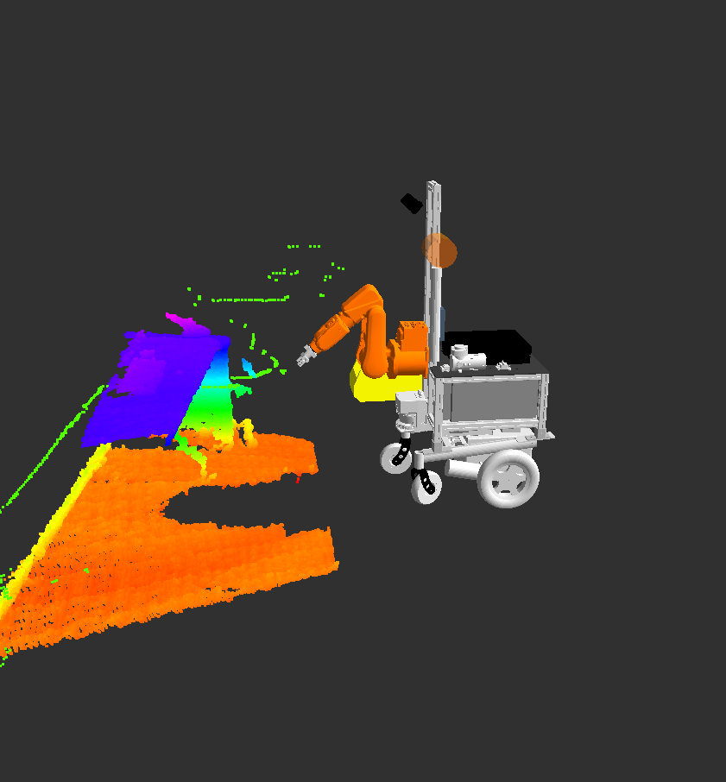

Figure 10:ABBY’s robot model, LIDAR data (green points), and Kinect point cloud (multicolored points) visualized in Rviz

In addition to providing the geometric definition of the robot, the robot model makes the Rviz robot visualization GUI much more usable. Because visualization meshes of the robot are defined, Rviz can render an accurate visualization of the robot in its current state. This is useful for verifying that the state of the robot in ROS matches the physical state of the robot. In an industrial environment, it would also allow a user to remotely monitor a robot without the need for a CCTV system external to the robot.

## Hardware Drivers

In order for ROS to read data from a sensor or send commands to an actuator, it must use a software driver implemented as a ROS node. The driver node for a sensor interfaces with the sensor hardware and publishes data as ROS messages to the appropriate ROS topic(s). The driver node for an actuator subscribes to actuator commands on the appropriate ROS topic and interfaces with the actuator hardware to execute the commands.

ABBY's Kinect camera and SICK LIDAR use preexisting open source drivers[14][15]. The ROS driver node for the mobile base was developed previously by this lab for other robots using the same hardware, and required limited modification for this robot[9]. The driver for the ABB robotic arm was written for this project in collaboration with the Southwest Research Institute (SWRI) of San Antonio, Texas.

The mobile base is controlled by software running on the cRIO, as described in section 3.7 above. The cRIO sends data to the PC containing information about the robot's pose, the state of the power supplies, and raw count data from the encoders. The PC sends angular and translational velocity commands to the cRIO and may send commands to the cRIO to activate or deactivate the emergency stop or to reboot the cRIO. These two tasks (sending and receiving data) are handled by two different ROS nodes. A third ROS node publishes pose information as a standard ROS message.

The receiving ROS node handles UDP packets from the cRIO. Encoder data is checked to ensure that all of the encoders are updating properly, and voltage data is checked to monitor the battery level and health of the power regulator. The results of these checks are fed into a ROS diagnostic updater, which can be used for operator feedback. Voltage information is also published to a custom ROS message so that other nodes on the robot can subscribe to the voltage data. Pose information is published as a custom ROS message type and sent to the odometry translator node. The odometry translator publishes the robot's pose using ROS-standard odometry messages, which are used in ROS's planning and localization packages.

The sending ROS node subscribes to ROS "twist" topics containing desired rotational and translational velocity from the mobile base trajectory planner and sends the commands to the cRIO as UDP packets. It also provides a ROS service to reboot the cRIO and ROS services to enable and disable the drive base motors with the emergency stop.

The gripper driver is a ROS node that runs natively on an Arduino's AtMega 328 microcontroller using the ROS Serial framework. It sends and receives ROS messages over the USB serial connection. A ROS node, included in the ROS Serial package, runs on the PC and acts as a transparent bridge between the ROS system and the ROS node on the microcontroller. The ROS node on the microcontroller publishes joint state messages describing the current position of the gripper plates and provides a ROS service to open and close the gripper. The Fuerte version of ROS Serial did not properly support ROS services[16]. In order to implement a service on the Arduino, changes were made to the ROS Serial bridge node and microcontroller code to enable support of services[17].

ROS Industrial is a project led by SWRI to develop a standard ROS framework for using ROS with industrial robots[18]. ABBY uses the ROS Industrial framework of messages and driver nodes to control the IRB-120 using the IRC5 Compact. ABBY's ROS Industrial driver was written specifically for this project, and has been incorporated into the ROS Industrial codebase.

The software on the IRC5 Compact is written in RAPID, ABB's proprietary programming language. The software running on the IRC5 Compact consists of a trajectory server, a state server, and a motion process. The state server periodically polls the positions of the joints in the arm and sends that information to the ROS system. The trajectory server receives trajectory packets from the ROS system and queues them for the motion process. When a complete trajectory is received, the trajectory server passes it to the motion process, which sends the arm to each point in the trajectory. In order to generate smooth motion through the trajectory, the intermediate points in the trajectory as being low precision waypoints. Because RAPID only has fixed-length data structures, trajectories must have a fixed maximum length. Paths generated for the IRB-120 with the current planner software have been experimentally determined not to exceed 250 points in most cases, so the maximum trajectory length was set to 250.

The robotic arm driver, like the mobile base driver, consists of two ROS nodes that communicate with a server running on the IRC5 robot controller. ROS trajectory messages describe the trajectory of a robotic arm as a series of points, with each point describing the position and velocity of all of the robot's joints. One of the ROS nodes subscribes to ROS trajectory messages, breaks them up into packets, and sends them to the IRC5 controller over TCP using a standard packet structure defined by SWRI. The other ROS node connects to the IRC5 controller over TCP and listens for state information from the controller, which is sent using another packet structure defined by SWRI. It publishes this state information, consisting of all of the robot's joint angles, as ROS joint state messages and ROS joint trajectory feedback messages. These messages are used by other ROS nodes to determine the position of the robot's arm and as feedback to the arm planning nodes[19].

# Experimental Software

Several experimental software packages were developed for ABBY, both to increase the capabilities of the platform and to test those capabilities. These include navigation and planning, calibration procedures, and investigations into industrial applications.

## Mobile Base Planning

In order for the robot to drive through a factory inventory, it must be able to plan trajectories through this environment. This task consists of localization, which determines where the robot is in its environment, high level path planning, which determines a feasible course from the current location to the desired location, and trajectory planning, which determines a sequence of velocities for the robot to execute in order to arrive at the desired location.

### Localization

In robotics, localization is the task of determining where the robot is. Localization methods can be classified into one of two groups. Relative localization methods determine the robot’s location with respect to the robot’s previous location, and absolute localization methods determine the robot’s location with respect to an absolute reference in the robot’s environment, sometimes called the “ground truth.” There are advantages and disadvantages to both classes of localization methods, and ABBY’s localization uses a combination of relative and absolute localization to mitigate the disadvantages and leverage the advantages of each.

Relative localization methods have several advantages over absolute localization methods. Relative localization methods tend to be computationally simple. Odometry, for instance, can be accomplished on a two-wheeled differential drive robot in only 14 mathematical operations (7 addition, 4 multiplication, and 3 trigonometric, as shown in Algorithm 1). Because relative localization is so computationally simple, it allows for high frequency update rates and implementation on embedded processors or in logic circuitry. Relative localization requires no knowledge of the robot’s environment (such as a map), and it does not require the robot’s environment to be instrumented with sensors (to track the robot) or beacons (for the robot to track). Localization methods can also be accomplished with relatively cheap sensors such as inertial measurement units (IMUs), optical flow sensors, and (in the case of wheeled vehicles) shaft encoders.









$$d_{r}=r-r_{0}$$

$$d_{x}=trans*cos(θ)$$

$$d_{y}=trans*\sin\left(θ\right)$$

$$d_{θ}=arcsin⁡(k_{θ}*\left(d_{r}-d_{l}\right))$$

$$θ=θ_{0}+d_{θ}$$

Algorithm 1: Odometry update from differential wheel encoder measurements. dr and dl are the difference in encoder counts since the last update. trans is the translation. dx and dy are the translation in the x and y directions. dΘ is the rotation in theta, and Θ is the heading.

However, relative localization methods all share one major disadvantage. Because each localization update is performed with respect to the previous, error accumulates over time. The source of the error varies from method to method. In the case of wheeled odometry, errors are usually due to wheel slip and the non-linearity of the trigonometric function used to estimate the heading. In the case of IMUs, the error is usually a result of the slow drift of the accelerometers and gyroscopes due to temperature variation. A well-calibrated relative localization system with an accurate observer model will still accumulate error over time, and the estimated position of the robot will slowly diverge from the true position.

There are several different types of absolute localization methods that use different types of sensors. Some methods use external sensors, such as cameras or radio frequency (RF) tracking systems to monitor the robot’s position. In order for a robot to use these methods, the operating environment must have already been instrumented with the necessary sensors. Other methods use sensors on the robot to track features of the robot’s environment and compare them to a known map of the robot’s environment[20]. Trackable features may already exist in the environment, such as ceiling lights in an office building, or may be added, such as position-coded labels on a warehouse floor. Systems with ranging sensors can track features of the geometry of the environment itself. To perform an update, all of these localization methods compare sensor data to a map or model of the environment to estimate the robot’s position. This means that they are dependent on an accurate map or model, which may not be possible in an environment with changing features. These methods also depend on the environment having suitable features to localize against. It is difficult to use these methods in featureless environments, such as open fields, and environments with many repeated similar or identical features, such as long hallways.

Although most absolute localization methods require an *a priori* map (or model) of the environment, one class of absolute localization methods perform simultaneous localization and mapping (SLAM). SLAM algorithms begin with no map of the robot’s environment and incrementally build one as they explore. For example, a SLAM algorithm using a LIDAR can exploit partially-overlapping LIDAR scans to register new scans with respect to previous scans. The translation and rotation required to register the scan can be used to determine the robot’s position with respect to the previous position. Each new scan increases the known region of the environment, slowly building a map..

ABBY’s sensor suite contains several sensors that can be used for localization. The encoders on the wheels are well-suited for odometry. The LIDAR and the Kinect depth camera can both be used for absolute localization using a number of methods, including both SLAM and *a priori* map localization algorithms. In addition, the Kinect camera could be used for localization based on patterns on the floor. Of these possible methods, odometry was chosen for relative localization, and Adaptive Monte Carlo Localization (AMCL) using LIDAR scans and an *a priori* 2D occupancy grid map was chosen for absolute localization.

ABBY uses odometry from the encoders on the wheels for relative localization. The physical state observer runs under the real time operating system on the cRIO, and publishes pose estimates with uncertainty (represented as covariance) to the ROS system at 50 Hz. Relatively high frequency updates to the robot’s pose are required as an input to the local planner, which generates velocity pairs at a rate of 12 Hz.

The odometry system does accumulate error over time. This error was characterized by operating the robot using only the relative localization system and manually driving it along simple geometric paths. When the robot is driven along a ten meter straight line with no observed wheel slip, the odometry error is 0.26 meters in the direction of travel and 0.90 meters perpendicular to the direction of travel. When the robot is driven in a circle with radius 1m for five laps with no observed wheel slip, the average odometry error over six trials is 1 meter in displacement and 26 degrees in heading. As expected, change in heading causes a greater error in the odometric localization. The greater error due to change in heading is a feature of the differential drive system on ABBY. For a differential drive system to turn, one or both wheels must slip, which introduces error into the odometry. In addition, rapid acceleration or deceleration of the robot causes the wheels to slip as the force exerted by the wheels exceeds the static friction between the wheels and the floor. This, in turn, introduces a sudden, relatively large error to the odometry.

It may be possible to improve the accuracy of the relative localization system by fusing in other sensors. Other researchers at Case [11], have fused rotational velocity data from a gyroscopic yaw rate sensor with odometry using an Extended Kalman Filter (EKF) . Because a yaw rate sensor is inertial, it is not affected by wheel slip. However, it does drift slowly over time. An EKF with variable measurement covariance, as described in [11] can improve the relative pose estimate, but the author of that research concluded that the improvement was minimal.

AMCL is an absolute localization method that models the robot's pose as a probability distribution[20]. The robot's pose is considered probabilistic to represent the uncertainty of the sensor measurements used to determine the pose. ABBY uses AMCL to match LIDAR scans to an *a priori* map. AMCL can theoretically solve the “wake-up robot problem,” in which the robot is initialized with no estimated pose. However, testing with ABBY showed that AMCL could not reliably solve this problem, and would often converge on a false pose estimate. Instead, ABBY is initialized to a pose at or near the true pose, with sufficiently large covariance that the true pose is within the likely region of the estimated pose. As the robot runs, the pose estimate will converge on the true pose. On ABBY, each pose update from AMCL takes approximately 200 milliseconds, which means that it can run no faster than 5 Hz.

Of course, AMCL is only possible with an *a priori* map. ABBY's maps were generated by the robot itself, using the same LIDAR used for AMCL and the gmapping SLAM package[21]. Gmapping uses a Rao-Blackwellized particle filter to generate maps as it localizes. Gmapping was considered as a possibility for the absolute localization scheme on ABBY. The main advantage of gmapping over AMCL is that it does not require an *a priori* map, making it easier to install the robot in a novel environment. However, gmapping on ABBY was unable to reliably traverse doorways without accumulating error. This was sufficient reason not to use it for localization. In addition, the maps generated with gmapping were manually edited to remove skews from going through doors.

Combining odometry with AMCL yields results that are better than either one alone. Because AMCL takes so long to compute, it cannot be used to approximate continuous localization. The local planner for the mobile base updates at 12 Hz, which is faster than AMCL can update. Whereas odometry is more suitable for the local planner, the error it accumulates as the robot runs eventually makes it unsuitable for global planning. In order to combine these two methods, two transforms are stored in the robot’s TF tree. One transform is between the robot’s base\_link (a coordinate frame with its origin on the floor between the robot’s wheels) to its parent, the odometric frame odom. This transform is updated by the odometric state estimator on the cRIO at 50 Hz and provides a higher resolution position estimate. Local planning is performed in the odom frame. The top level transform is from the map frame (the absolute coordinate system) to the odom frame and the map frame. This transform is updated by AMCL, which runs an update every time the robot moves more than 0.05 meters in translation or 0.1 radians in rotation. On each AMCL update, the transform from the map to odom frame changes such that it cancels out any error in the tranform from the odom frame to the robot's base\_link. Over a long period of operation, the odom transform may accumulate significant error, but the transform from the map frame to the base\_link remains accurate because of the absolute localization updates.



Figure 11: The map, odometry, and base frames of the robot localization system.

### Mobile Base Trajectory Planning

One of the major tasks for a mobile robot is navigation through its environment. In order for the robot to get parts from inventory, it must first travel through the inventory shelves to the location of the parts. In an industrial application, the location may be retrieved from an inventory database, or it may be specified by a human operator, but the robot's task is the same. From its current location, the robot must plan a path to another location in its environment. The path must avoid obstacles, and it should be as direct and efficient as possible. The robot must then generate a trajectory to follow the path and travel to the goal location. The trajectory cannot violate the dynamic constraints of the robot. Given a trajectory, the robot must execute it by controlling the actuators as accurately as possible to adhere to the desired path and trajectory.

ABBY's differential drive system allows it to move forward and backward and rotate in place, but not move laterally. This makes navigation and control somewhat more difficult than for a holonomic drivebase such as the caster drive system on the Willow Garage PR2.

Speed control on ABBY was implemented by previous researchers as a pair of PID controllers, one for each wheel. The PID controllers are implemented on the cRIO's FPGA for speed and robustness, with loop closure rates of 100 Hz. A simple geometric algorithm (see Equations 1 and 2), implemented on the cRIO's PowerPC processor, is used to convert twist-style commands (forward and rotational speed) into speed setpoints for each wheel. Each PID controller's setpoint is specified in meters/second and its output is an 8-bit signed integer These signed integers represent the desired voltage to be output by the Sabertooth motor controller, with -127 being full reverse and 127 being full forward. Since the Sabertooth motor controller can vary its voltage output from -24 volts to 24 volts, the 7 bits of speed resolution in each direction correspond to a voltage output resolution of about 189mV. The PID controllers on ABBY were originally tuned for another HARLIE-class robot with a different weight distribution[22]. With minimal returning, ABBY's minimum achievable forward/reverse speed is 0.1 m/s and minimum rotational speed is 0.35 rad/sec; other robots based on the same mobility platform were able to achieve 0.1 m/second and 0.1 radians/second respectively.

$v_{left}=v_{x}-\frac{w_{track}}{2}*v_{yaw}$ 1

$v_{right}=v_{x}-\frac{w_{track}}{2}*v_{yaw}$ 2

The higher-level components of navigation are path and trajectory planning. Path planning is the task of determining a path from the robot's current location to a desired pose. Trajectory planning takes the path and determines a series of velocity commands to move the robot through the path without violating the acceleration and velocity constraints of the robot. On ABBY, these tasks are performed by a global and a local planner, respectively.

NavFn[23], the global planner node available in the ROS navigation stack, operates on a grid-based global costmap populated by data from the LIDAR. Given a desired pose, NavFn finds a minimum-cost path using Djikstra's algorithm[24]. This path is defined as a series of intermediate robot poses along the path. NavFn successfully plans paths for ABBY in relatively open environments, but because it assumes a circular robot base, it will sometimes plan impossible paths in crowded environments.

The local planner generates trajectories to follow the path produced by the global planner; it operates on a local costmap populated by data from the LIDAR. The robot performs local planning using a trajectory rollout approach[20], which forward-simulates translational and rotational velocities and evaluates the resulting trajectories for proximity to obstacles, proximity to the goal, and adherence to the global path. These scores are weighted and summed to determine the velocity command’s score. The highest scoring velocity command is sent to the mobile base driver.

## Inverse Kinematics solver

An important part of robotic arm planning is an inverse kinematics solver. Given a pose in the robotic arm's work envelope, an inverse kinematics solver determines a set of joint angles that would place the end effector at that pose. Because not all poses have possible solutions and some poses are degenerate cases, analytical inverse kinematics solvers are mathematically complex.

ROS includes a kinematic solver in the kinematics\_constraint\_aware package that wraps the inverse kinematics solver of the Orocos project's Kinematics and Dynamics Library (KDL)[26]. The KDL solver is a numerical solver that uses Newton-Raphson iterations. The KDL solver takes joint angle limits into account in evaluation of its solutions, only returning a solution with valid joint angles. However, the KDL solver will often fail for achievable poses and, because it uses an iterative numerical method, runs slowly, on the order of tens of milliseconds.

To counteract the problem of the KDL solver failing for achievable positions, the solver was wrapped in a method to retry the search on failure. When the solver fails to find an inverse kinematics solution for a desired pose, the solver is reseeded with randomly selected joint values and called again, up to 100 times. To test the solver, poses were generated using forward kinematics of simulated joint angles. Since the poses were generated by forward kinematics, they are guaranteed to be achievable. Many of the test poses were not solvable by the unmodified kinematic solver, which only made one attempt at a solution. When the number of attempts was increased to 100, the success rate was 32% for solvable poses. As shown in , most inverse kinematics requests are solved in under 20 iterations or will fail. Since the seed is random, the number of requests needed to solve for a difficult pose is probabilistic, and though some positions are more difficult to solve for using KDL’s iterative approach, there is no guarantee that the solver will succeed or fail for a given pose. The resulting inverse kinematics solver is suitably reliable, though slow, taking as long as 3.5 seconds before determining that a pose is unsolvable. This is acceptable for the robot at this time, but a faster, more reliable inverse kinematics solver will be necessary in an industrial installation.

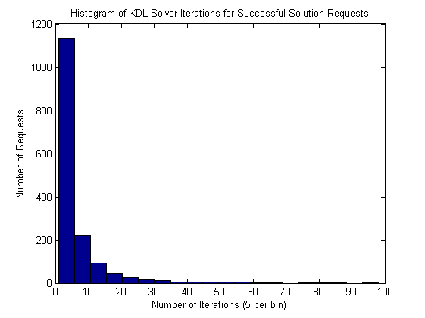

Figure 12: A histogram of successful requests from the test of the KDL inverse kinematics solver, showing the distribution of iterations required to find a solution.

The OpenRAVE project includes the IKFast kinematic solver tool[27], which analyzes a kinematic chain and generates C++ code for an inverse kinematics solver for that chain. The solver it generates is a closed-form analytic solver, meaning it runs very quickly (<1 ms) and can handle the vast majority of achievable poses, including degenerate cases. The greatest limitation of IKFast is that it does not take into account joint limits, but assumes that all joints can rotate freely. This means that IKFast will often generate solutions that are unachievable for a rotation-limited robotic arm.

The ROS wrapper for IKFast rejects solutions that violate joint constraints, but IKFast will only return the first eight IK solutions it finds, and it is likely that none of these solutions will satisfy joint constraints, particularly for degenerate cases. When this happens, the ROS inverse kinematics service fails, despite the possible existence of a valid solution. It may be possible to rewrite the IKFast compiler or modify the generated code to work with joint limits, but at this time, IKFast was determined to be unsuitable for arms of ABBY's geometry due to the high incidence of solver failure.

## Arm Navigation

ABBY's arm navigation package is closely based on the standard ROS arm navigation package, which is generated from a URDF by a tool called the Planning Description Configuration Wizard. This wizard allows the user to define a manipulator kinematic chain from a URDF file and then generates an arm navigation application, including the necessary launch files for an inverse kinematics plugin, a planner, and a collision environment server. This "default" arm navigation application was augmented with filtering nodes for the Kinect data going into the collision environment and the modified KDL inverse kinematics plugin described above.

The trajectory planner for the arm is the default planner available with the ROS arm navigation package. It uses a sample-based planning algorithm from the Open Motion Planning Library called Single-Query Bi-Directional Probabilistic Roadmap Planner with Lazy Collision Checking (SBL)[28]. SBL plans collision-free paths for the arm and publishes these paths as ROS trajectory messages, which the ROS Industrial arm driver executes. Because SBL performs all of its planning in joint-space, the arm navigation application uses the inverse kinematics plugin described above to convert goal poses into joint space before planning paths to them.

### Collision Detection

The robot uses the ROS node Collider to maintain a collision map, a 3D occupancy grid represented by an Octomap oct-tree. The collision map is populated by data from filtered Kinect point clouds. In addition to this "raw" map, a collision environment is maintained, which contains information from this map and keeps track of detected objects such as the manipulable objects detected by the tabletop box recognition system described below. The objects are given IDs and stored in the map as meshes or geometric solids, enabling the arm navigation code to make decisions about whether collisions are allowable.

The arm navigation code navigates around obstacles in the collision environment, including the robot itself, preventing the robot from damaging itself and the objects around it. Collisions can be selectively allowed between robot links and objects in the collision environment. For instance, it is impossible to pick up an object without the jaws of the gripper colliding with it. When creating a request to make the final approach to pick up an object, collision detection between the gripper jaws and the object is disabled, allowing the robot to pick the object up while still preventing collisions between the robot and other obstacles.

### Kinect Data Filtering

The Kinect's field of view includes the robot's arm, which the collision detection process would classify as obstacles. This causes the robot to freeze because it is in collision with a perceived obstacle, even though the obstacle is the robot itself. In order to prevent this, the Kinect point cloud is pre-filtered to remove points that are within the robot volume, which is simulated by padding the 3D model of the robot generated from the URDF. The resulting point cloud, which has all points within the robot removed, is used for all collision monitoring and object detection. Unfortunately, this is a computationally intensive task, consuming one full core of the PC’s processor.

## Tabletop Box Manipulation

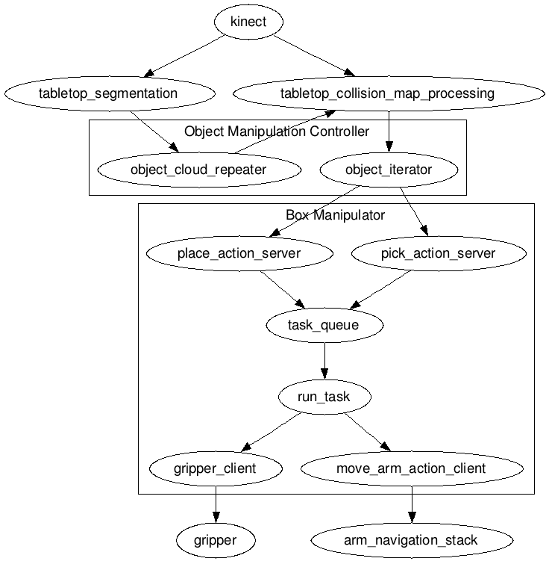

Figure 13: The box manipulation pipeline. Data from the Kinect is used to locate boxes on a table, which are then picked up and placed in the bin.

Once ABBY arrives at the desired location in the inventory, it must identify objects and pick them up from the inventory shelves. This is an area for future researchers to improve upon, but a basic object perception and manipulation system was implemented as a proof of concept. The system uses several object detection nodes developed by Willow Garage for the PR2 robot, as well as two nodes written specifically for this project.

### The Manipulation Controller

The Object Manipulation Controller was written specifically for this project and serves as the central control node, translating and routing messages between the perception and manipulation nodes. It provides a callable method pick\_objects(), which performs the task described in Algorithm 2.

detected\_objects = tabletop\_detection(kinect\_data)

for each object in detected\_objects:

if graspable(object):

pick(object)

place(object, bin)

stow\_arm()

Algorithm 2: The process for detecting, picking up, and stowing the objects on a table

The tabletop\_detection() step is performed by the tabletop\_object\_segmentation package, developed by Willow Garage [29] for the PR2 robot. This software identifies a tabletop surface in a point cloud from the Kinect using RANSAC [30] and adds it to the collision environment as an object. Objects on top of the table (detected\_objects) are segmented into separate point clouds and inserted into the collision environment as Graspable Objects. These Graspable Objects are used later by the manipulation package during the pick() step to identify and locate the objects in the robot's environment. The pick() and place() steps are performed by the box manipulator node, which exposes them as action services using a standard pick-and-place API defined in ROS. This standard API allows the box manipulation package to be easily replaced by a new manipulation package, or the manipulation controller to be replaced by a more sophisticated package. In the final step, stow\_arm(), the arm is moved to a predefined stowed position, which minimizes the robot's footprint while it is driving.

### Box Manipulation

The box manipulator node was written for this project to be able to lift small boxes from a shelf or table and place them. It provides two services—one to pick up a graspable object, and one to place the currently held graspable object at a set of coordinates.

When the manipulation controller calls the pick service on a Graspable Object in detected\_objects, it uses another node created by Willow Garage for the PR2 to fit a bounding box to the Graspable Object's point cloud. Since the objects being manipulated are themselves boxes, the bounding box is a fairly accurate representation of the object. This bounding box is then used to generate an approach path composed of two poses. The first is a pregrasp pose close to the box, with the gripper pointed at the box center and the gripper jaws parallel to the sides of the box. This pose is sent to the arm navigation package, which generates a trajectory and moves the arm to the pose. The second pose is the grasp pose, with the box between the gripper jaws. This pose is also sent to the arm navigation package, and once the robot is in the grasp pose, the gripper is closed around the object.

Once the gripper is closed around the object, the object manipulation controller calls the place() service with a pose in the robot's onboard storage bin as a target. This service sends the pose to the arm navigation package, which generates a trajectory and moves the arm to the bin. The gripper is then opened.

## Calibration

In order for the point cloud data from the Kinect to be usable for arm navigation, the positions of the Kinect and the arm must be correctly registered in 3D space. Because the position of the Kinect camera's optical frames within its housing are not precisely known, it was necessary to perform a simple extrinsic calibration routine to determine the position and yaw angle of this frame.

To determine the height and yaw angle, the robot was placed so the Kinect had an unobstructed view of the floor in front of it. RANSAC was used to fit a plane to the floor, and the transform from the fitted plane to the Kinect was calculated. A similar method was used to determine the x position of the Kinect. The robot was placed so that the Kinect had an unobstructed view of a wall at a known distance in front of it, and RANSAC was used to fit a plane to the wall. The distance of the wall plane was then used to calculate the position of the Kinect. The y position of the camera was estimated known to be centered on the robot, and the y-positions of the lenses were determined from the CAD model of the Kinect.

With the position of the Kinect now known, it was necessary to precisely determine the pose of the arm relative to the Kinect. Due to the length of the arm, a small error in the orientation of the arm base pose could cause significant disparity between coordinates in the Kinect's frame of reference compared to the position of the robot's gripper calculated using forward kinematics. The pose of the arm base was originally taken from the CAD models used to design the robot, but the model’s fidelity to the robot was not sufficiently precise.

A more precise transform was calculated from test data using Mathematica. Given a set of data points, each one containing the position of the tip of the gripper with respect to the Kinect, measured from a manually-selected point in the Kinect point cloud, and the pose of the gripper with respect to the base link of the arm, calculated by ROS's TF server using forward kinematics, the program calculates the transform (translation and rotation) between the Kinect and the arm base link that minimizes RMS error in the gripper tip position. This program was run using an input consisting of forty-two data points, and the resulting transform was used in the robot's URDF to define the position of the arm.

## QR Code Recognition and 3D Localization

Mobile manipulators in industrial settings can benefit from information about the objects they manipulate. Most of the explorations of object manipulation have been directed toward general purpose object recognition and manipulation, but the problem of determining how to pick up an object can be greatly simplified by simply putting manipulation information on the object itself. For more complex information, the object could link back to an entry in a database. Properties salient to mobile industrial manipulation, such as grasp affordances, mass, volumetric data, and visual cues for registration and localization, can all be encoded into visual or RFID tags on manipulable objects. To this end, an exploration was made into using the Kinect in conjunction with a higher-resolution camera to read QR code tags on boxes and use the QR code to perform 3D localization of the box.



Figure 14: QR Level 3 code (Source: Wikipedia, licensed under Creative Commons Attribution Share-Alike License)

QR codes can hold up to 3 kilobytes of data, or 174 bytes with 7% error correction. They include 3 "finder square" fiducials, which can be used to acquire and correct the skew and size of the code. QR codes are already used throughout the automotive industry for part labeling[31].

Information about how to grip an object can be stored in a small amount of data in a QR code on an object. This information, which I call an “affordance cue,” contains, in a compact form, information that aids a robot in deciding how to manipulate an object:

* 1. If an object has handles, the affordance cue contains the information necessary to define the handles and locate them relative to the tag.
  2. If an object can be lifted only from the bottom, as with a fork-lift, the affordance cue contains information necessary to locate the bottom of the object relative to the tag.
  3. If the object can be grabbed from the sides by a gripper, the affordance cue contains gripping force constraints and the information necessary to locate the sides relative to the tag.



Figure 15: A box localized using the QR code. Red dots are the QR code finder pattern. Blue is the projected handle center. Green are the handle corners.

Using a Kinect sensor and MatLab, a rudimentary proof-of-concept was tested for boxes with handles on top. Because the Kinect image sensor does not have high enough resolution to read QR codes, it must be supplemented with a second, higher resolution camera extrinsically calibrated to the Kinect. This part of the detection was simulated, and the QR code data manually entered into the program. The coordinates of the three finder points in the Kinect RGBD image are then used to get the positions of the three finder points in 3D space. Again, because a high resolution camera was not available, this step was simulated by manually picking points. Using the 3D coordinates of the 3 finder points, it is possible to localize the QR code in 3D space, including both position and orientation. Using the location of the tag and the tag’s information about the handle's location relative to the tag, the handle can be located, allowing a robot to grasp it without knowing any other information about the box. The results are shown in Figure 15 above.

Because the Kinect RGB camera does not have sufficiently high resolution for the task, these experiments were not performed on the robot. However, this line of research is one of the planned future purposes of the robot, once a high resolution camera can be acquired, mounted, and calibrated to the Kinect.

# Industrial Safety

Mobile robots, particularly experimental platforms, require safety systems to disable them. These systems fall into two major categories. Reflexive collision avoidance systems keep robots from colliding with humans interacting with the robot. Emergency stop systems are used to disable the robot in case it does something unsafe or unexpected. Both types of systems are necessary in an industrial robot, especially one that does not operate in a cage or with guards, neither of which are practical for a mobile robot.

## Reflexive Speed Limiting

A key safety feature of many robots is reflexive speed limiting or halting. Reflexive halting uses sensors to detect obstacles in the robot's path and prevent motion that would result in a collision. Reflexive speed limiting is particularly important for robots that operate in shared environments with people, because people can suddenly move into a previously clear robot path, endangering themselves and the robot. Whereas a planner will create safe paths for a robot around static obstacles, paths may be invalidated by moving obstacles such as people, and the planner may react too slowly to prevent a collision. Reflexive halting operates more quickly and on a lower level than planning and trajectory generation, and can override the velocity commands from the trajectory generator.

At this time, ABBY does not implement a reflexive speed limit for the base or the manipulator. Because both operate at low speeds, the robot does not pose a safety threat to the operator and can be easily stopped with the emergency stop system described below. Before the robot can be tested or deployed in an industrial environment, and to allow for faster movement, reflexive speed limits must be imposed. This section describes proposed methods for reflexive speed limiting.

### Reflexive Halt Methods for Mobile Bases

ABBY’s local planner will not allow for collisions with obstacles seen by the LIDAR, and it updates velocity commands at 12 Hz. Although this is sufficiently safe for testing, a more robust solution would be necessary in an industrial setting. Mobile robots often implement a reflexive halt as shown in Algorithm 3. For example, if a measurement source such as a LIDAR reports that there is an obstacle in front of the robot at close range, the robot's velocity would be limited to turning and reversing. This approach is effective, but can cause difficulties in navigating tight areas, where there may be enough space for a robot to navigate through obstacles if it does so carefully.

Given:  
 Sensor measurements, M  
Do:  
 for each measurement m in M:  
 if(dangerous(m)):  
 prevent motion in direction of m

Algorithm 3: A simple reflexive halt algorithm. If an obstacle is close to the robot, the robot is prevented from approaching closer.

Another approach to reflexive halting was described by Chad Rockey in his masters thesis[32]. This approach, called Reflexive Avoidance Plus, was developed for a smart wheelchair, which must operate in crowded areas around people. Reflexive Avoidance Plus uses velocity limiting rather than preventing motion altogether. When a sensor detects an obstacle in the robot's path, it limits the maximum velocity in that direction using a scaling function based on the distance of the obstacle from the robot. This approach prevents the robot from colliding with an obstacle (the maximum velocity is zero below a certain threshold distance), but allows low speed progress toward an obstacle. Because the robot approaches the obstacle at lower speed, it can safely get closer to obstacles.

Since the Reflexive Avoidance Plus method described by Rockey was implemented on a robotic platform of similar size and speed to this robot, it would be a good candidate for this robot. However, there is some work still to be done to adapt the code, which was designed specifically for the wheelchair, to ABBY.

### Reflexive Halting for Manipulators

In addition to the mobile base, ABBY's robotic arm poses a risk for collisions. In industrial situations, manipulators are kept inside safety cages to prevent people from interfering with them or getting injured. A safety cage is not a possibility for a mobile manipulator, so another solution is necessary. A reflexive halt for the manipulator allows it to operate safely in the presence of people and obstacles without a safety cage.

Like the mobile base planner, the planner for the arm generates collision-free paths. However, the planner for the arm does not replan at all once it commits to a trajectory. The trajectory is generated and sent to the IRC5 for execution, and then ROS waits for the trajectory to be executed. If something enters the path of the trajectory, the robot does not alter the current trajectory. This makes the robot unsafe to operate around humans above a certain joint speed.

Rethink Robotics, with their robot Baxter[33], solved the problem of operating an industrial robot without a safety cage with a mechanical and software solution that relied on force feedback and serial-elastic actuators. Because all of Baxter's joints are elastic and its arms are so light, it can safely collide with people and obstacles. It also uses force feedback in its joints to detect these collisions and become passive, allowing people to push it around. Because ABBY's robotic arm does not have serial elastic actuators or force feedback in the joints, this solution is not possible.

Using the Kinect sensor, it would be possible to implement one of several possible reflexive collision avoidance methods on ABBY. One method would be to halt arm motion when an obstacle enters the arm's work envelope and suspend arm motion until the obstacle leaves the work envelope. Although this is arguably the safest solution, it can cause the robot to become stuck in the stopped state. If an inanimate obstacle is brought into the robot's work envelope and left there, the robot will never re-enable the arm.

To resolve this problem, the reflexive halt behavior can be augmented as shown in Algorithm 4. In this algorithm, the currently planned path is repeatedly checked for dangerously close objects (such as people) until execution is completed. If an object enters the dangerous area, the robot stops execution of the trajectory and waits. If the obstacle leaves the area before a timeout is reached, the robot resumes execution of the trajectory. If the obstacle does not move, the robot will attempt to retry planning to move around the obstacle to accomplish its goal. This reflexive halt algorithm has two advantages over the naïve algorithm described in the previous paragraph. First, it does not stop for obstacles that enter the work envelope but do not interfere with the planned motion. This allows humans to work alongside the robot and interact with it by giving it objects or taking objects from it. Second, it will plan around stationary objects that enter the work envelope, allowing a person to leave an object in the work envelope without stalling the robot.

Given:  
 Current Plan P, Measurements M  
Do:  
 for each state s in P, measurement m in M:  
 if(dangerous(m, s)):  
 halt  
 wait for obstacle to move or replan

Algorithm 4: An algorithm for reflexive halting for a mobile manipulator. If an obstacle enters the manipulation path, the robot waits, then replans.

The National Institute for Standards and Tests (NIST) has developed an algorithm to determine a safe separation distance S for a human to approach a robot. This is described in Equation 3 below, where KH is the speed of a moving human, KR is the speed of the robot, TR is the reaction time of the human, TB is the braking time of the robot, B is the robot braking distance, and C is a distance to account for measurement uncertainty[34].

$S=K_{H}*\left(T_{R}+T_{B}\right)+K_{R}*T_{R}+B+C$ 3

NIST researchers used this equation, LIDAR scanners, and a Kalman filter to track humans moving through the robot's work envelope and determine whether a human had entered a danger zone around the robot (if the distance from the robot to the human is less than S). This method completes Algorithm 4 by filling in the dangerous() function. In order to implement this algorithm on ABBY, parameters B and C would first have to be determined for this platform. Then, the algorithm would have to be written as a ROS node and tested on this robot.

## Emergency Stop System

### E-Stop Systems Used in This Lab

The Case Mobile Robotics Group has used a few emergency stop systems in its robots. All of the HARLIE-class robots developed for the Intelligent Ground Vehicle Competition used a commercially-available wireless relay system from Remote Control Technologies. This system consisted of the remote control relay in series with an onboard disable switch and a second relay switched by an active-high enable signal from the cRIO, which is software-controllable. These three switches (one manual and two relay) control the current through the coil of a solenoid, which in turn switches the power to the motor controller on and off. This system has one critical flaw, which is that there is no “heartbeat” from the wireless remote to the remote control relay. This means that if the battery in the wireless remote dies or the radio communication is lost between the wireless remote and the robot, there is no way to remotely stop the robot, nor is there any indicator to the operator that the robot cannot be wirelessly stopped.

OTTO the smart wheelchair could operate in either autonomous or manual control modes, and used a custom remote system to enable and disable autonomous mode. Using the GPIO mirroring function of a pair of XBee 2 Pro wireless network modules, a digital signal was transmitted from a remote control unit to the input of the Arduino controlling the wheelchair’s motor controllers, disabling the autonomous functions of the wheelchair when a button was pushed on the remote. Because the XBee wireless modules' GPIO mirroring has a programmable timeout and default output state, this system automatically disabled autonomous functions if communication was lost between the remote and the robot. However, this system relied on an Arduino microcontroller and was not designed as an emergency stop system, but as a switch between autonomous operation and normal (joystick) operation of a wheelchair.

### E-Stop Requirements for This Robot

This robot has several requirements that motivated the development of a new emergency stop system combining the merits of the HARLIE-class stop system and the OTTO remote switching system. First, the emergency stop system needs to be able to switch the high current, 24 volt rail providing power to the motor controllers. Second, the system needs to be able to activate the 24 volt emergency stop input on the IRC5 robot controller, which must be electrically isolated from the rest of the robot's DC electronics. Third, the system must monitor four sources, stopping the actuators if any of them are disabled:

* 5 volt active-high enable signal from the cRIO, which is controlled by the ROS software
* 24 volt active-high emergency stop signal from the IRC5, which is controlled by the emergency stop switches on the IRC5 and FlexPendant and by RAPID software.
* Twist-lock stop switch mounted on the robot (The robot is disabled if the switch is opened or disconnected.)
* Wireless remote control with a heartbeat signal of at least 1Hz

Fourth, the system should be implemented entirely in hardware for safety reasons. Software faults in a safety system are unacceptable and adequate testing of a software system would be too time-consuming for this project. Fifth, the remote control unit should have some feedback as to the state of the four emergency stop sources described above.

### Version 1 Prototype

Given the requirements, an emergency stop system was designed and fabricated using printed circuit boards. The schematic of the system is shown in Figure 16 and Figure 17. The system consists of two circuits, a remote control and an emergency stop circuit on the robot.



Figure 16: A design for an emergency stop remote.



Figure 17: A design for an emergency stop receiver and aggregator.

The remote circuit uses an XBee radio module's GPIO mirroring function is used to transmit the state of the emergency stop button to the emergency stop circuit on the robot in the same manner it was used on OTTO. This system also uses the GPIO mirroring function to send the states of the onboard emergency stop sources to the remote, where they are displayed on LEDs. Because a twist-lock style emergency stop button was not available, an S-R latch was used to latch the state of a normally-open momentary pushbutton, requiring that the remote be powered off and back on again to reset the wireless emergency stop. If communication between the XBEE modems in interrupted for any rason, DIO3 in the emergency stop circuit goes low, disabling the robot.

The emergency stop circuit on the robot has inputs for the onboard emergency stop button, the cRIO's enable signal, and the emergency stop output of the IRC5. The input from the IRC5 goes into an optoisolator IC because the I/O on the IRC5 is floating relative to the rest of the robot's DC systems. A 7400 series AND IC is used to generate logic signals to enable the drive base and the IRC5's emergency stop input. The drive base logic signal controls a Darlington transistor, which in turn switches the coil of a solenoid that controls the drive base in the same manner as on HARLIE-class robots (not shown in Figure 17; see Figure 4). The IRC5 output logic signal switches the 24v General Stop input of the IRC5 using an optoisolator IC.

These circuits were prototyped and installed on the robot. Because the RAPID software running on the IRC5 was not configured to output the emergency stop state, the input from the IRC5's emergency stop was defeated by installing jumper J1. Additionally, testing showed that the 4N35 optoisolator used to switch the IRC5's emergency stop could not switch enough current to enable the emergency stop circuit, causing the IRC5 to go into General Stop mode seemingly at random. The ability to control the IRC5’s emergency stop state was defeated by disconnecting the IRC5 Stop output and shorting the General Stop input on the IRC5. These two changes completely decouple this emergency stop circuit from the IRC5, meaning it no longer meets requirements 2 and 3b described above. Furthermore, the wireless link between the XBee modules proved unreliable, causing the system to momentarily switch into emergency stop mode seemingly at random. Extensive bench testing of the system suggests that this problem is caused by an insufficiently reliable power supply to one or both of the XBee modules. In order to make the system usable, the wireless emergency stop was replaced with a twist-lock style emergency stop button on a ten foot wired tether. This modification means that the system no longer meets requirements 3d and 5 described above. The system does reliably control the power to the drive base, providing a level of safety for the robot, but revisions are required to make the system function as specified.

### Version 2 Design

A revised version of this emergency stop circuit was designed and portions of it prototyped, but it has not been tested. This version should fix the problems discovered in the first version of the emergency stop.



Figure 18: Revised emergency stop remote ciruit.



Figure 19: Revised emergency stop receiver/aggregator circuit.

To allow the system to stop the IRC5, the optoisolator on the output of the emergency stop circuit was replaced with a relay module, which will more reliably switch the General Stop input of the IRC5. To complete integration with the IRC5, the RAPID software must be modified to output the current General Stop state to a GPIO, which should be connected to the IRC5 input of the emergency stop circuit.

To solve the wireless communication issues, the power supply in the remote was replaced with a 3.3 volt regulated boost supply, which should be much more reliable, and bypass capacitors were added to the power rails of the XBee modules on both the remote and the emergency stop circuit. Testing has shown that the XBee modules are reliable when a sufficiently clean and reliable DC supply is available to power them.

In addition to solving the problems described above, some small changes were made to improve the circuit. To reduce the power consumption of the emergency stop circuit and reduce the heat produced by the onboard power regulator, the Darlington transistor used to switch the coil of the drivebase enable solenoid was replaced with a MOSFET circuit that performs the same function. To make the system easier to use and more reliable, the momentary switch and latch used on the previous version was replaced with a twist-lock style emergency stop switch.

Although this system has not been constructed, its constituent parts have been tested individually. The MOSFET switching circuit has been confirmed to work with a resistive load equivalent to the coil resistance of the solenoid used to switch the drive base power rail. The power supply circuit in the remote has been tested and provides a reliable 3.3 volt power supply from a pair of AA batteries. The use of a relay instead of a transistor to control the General Stop input is in line with recommendations from ABB's documentation, and the relay used meets the requirements. If the necessary components can be acquired for this emergency stop circuit, it should be able to meet all of the requirements described above.

# Experimental Results

## The Validation Task

In order to validate the basic functionality of the robot, a simple task was devised to simulate part of the task of retrieving an assembly kit from factory inventory. The task is designed to test the localization and navigation systems, the arm navigation system, and the object recognition and obstacle avoidance using the Kinect. The task is as follows

* 1. Beginning at the operator’s station, drive to a predetermined location near a table a few meters away. This validates the performance of the drive base hardware and the localization and base navigation systems.
  2. Once at the table, locate at least one of the four small manipulable boxes on the table. This validates the Kinect and the tabletop object recognition system.
  3. Perform the pick() operation on the box to lift it from the table. This operation is described in above. This step validates the use of the Kinect to provide target poses for the arm, the inverse kinematics solver, the arm and gripper hardware, and the box manipulation software.
  4. Perform the place() operation to place it in the bin. This operation is described in Tabletop Box Manipulation above. This step provides further validation of the arm, gripper, and manipulation software.
  5. Drive back to the operator with the box in the bin. This provides further validation of the drive base hardware and software.

This task is meant to simulate the act of driving through a factory to a shelf (represented by the table), picking up an item for a kit, and delivering it to the assembly station. In an actual factory environment, steps 1 through 4 would be performed repeatedly until every item in the kit was retrieved.

## Validation Results

[hey write some stuff]

## Mechanical and Electrical Systems

### Wheelchair Drivebase

The wheelchair drive base was only just adequate for this task. The main problems with the drive base are related to its adaptation to robotic control. The odometry is not very accurate, requiring the use of AMCL for localization, which might not be practical in industrial environments. Furthermore, the drivebase proved problematic for precision control. The control algorithms packaged in ROS were primarily developed for a holonomic drive base, which may be the cause of some of these problems, but many researchers have bad better success with these algorithms on differential drivebases, so it is reasonable to assume that this drivebase is particularly problematic.

On the lowest level, the PID controllers do not regulate the robot speed well. This was evident in the robot’s inability to turn at speeds below 0.35 radians per second, but was also illustrated by the robot drivetrain being back-drivable and variability in robot performance as the batteries discharged. The PID controllers were written by previous researchers in LabVIEW, and rewriting them was beyond the scope of this project. Attempts to retune the PID controllers quickly resulted in instability, particularly when turning. It was possible to increase the proportional gain by a factor of two without introducing instability, and this made a minor improvement to the robot’s performance.

The global planner works well for this drive base, generating a spline from the robot’s current position to the desired pose. However, the local planner has difficulty with the robot. On ABBY, trajectory rollout planning sometimes results in unintuitive behavior as the robot approaches the goal. Namely, the robot will sometimes overshoot in its final rotation, forcing it to turn all the way around, sometimes more than once, to reach the proper heading. This problem is probably because of the poor low level control, combined with the robot being a long moment arm, with the wheels at the back and the arm at the front. The robot shape also complicates planning because the planner must be able to maneuver through tight spaces, and the robot needs are large area in order to turn freely without hitting something with the arm.

### Chassis Design

The frame design proved to be somewhat problematic in a few ways. First, although Bosch rail made quick prototyping possible on the robot, it also made it difficult to reliably fix some components of the robot in place, namely the arm. The arm is held to the vertical rails of the robot using T-slot nuts, and over the months that the robot was operated, it slipped down a few centimeters, requiring it to be raised and retightened. Second, the placement of the arm itself is less than ideal for the task the robot must perform. The center of the arm’s work envelope is directly in front of the center of the point where the base is mounted to the robot. Since the base is mounted at about 1 meter off the ground, that puts the center of the work envelope only slightly above table height. Being able to reach under the table is useless, so much of the arm’s work space is unused. The arm should be raised higher if it is to be used for tabletop object manipulation and mounted horizontally. Last, the onboard storage bin’s location was chosen based on the available space within the reach of the arm, which was limited. A better location or a better bin design should be considered. Raising or reorienting the arm may open up more options as to the location of the bin.

### The ABB Arm System

This system performed well, but has a few drawbacks. First, the IRC5 Compact controller dominates the robot volume, limiting the space available for other robot hardware. A smaller controller would have made the design of this system easier and resulted in a more elegant design. Second, the IRC5 Compact runs on 220 volt AC power. Finding a suitable inverter to create this from the 24 volt batteries was one of the more difficult parts of the system design. Finally, the RAPID programming environment provided by ABB is antiquated, limited, and constricting. Although it performs excellently as a robot controller, it does not expose the lower level control of the arm, such as joint torques, which would be useful for performing more advanced control techniques than position control. Fortunately, this robot’s tasks are achievable using only position control, which the ABB system does very well.

### Gripper

The gripper was one of the biggest problems with this robot. It was chosen from a limited selection of available grippers, and is not appropriate to this robot’s task. The gripper is a very simple design, with only an open and a closed position and no grasping ability. This limited the manipulation capability of the robot to simple boxes that were within the size range of the gripper. Although the gripper’s overall size is about right for the boxes that the robot must manipulate, the difference between its open size (6 cm) and its closed size (7.8 cm) is only 1.8 cm. This makes picking up objects difficult because the gripper must be very precisely placed. Unfortunately, this is difficult or impossible using the Kinect. A gripper with a longer throw between its open and closed positions would have been able to pick up a wider range of objects sizes and also pick up objects that are not precisely centered in the jaws. Finally, the gripping force of the gripper was only somewhat adjustable. The solenoid valve used to open and close it only works at above 210 kPa of pressure, which set the lower bound for gripping force. This means that the robot cannot pick up delicate objects without crushing them. The paper boxes used in the validation task were only barely stiff enough to withstand this force.

### Battery Life

Three tests were performed to determine the life of the battery. In each test, the test process was run until the battery voltage reached 21.5 volts DC, which was considered the critical shutdown voltage. At this point, each cell in the lead acid battery has been depleted to about 1.8 volts, or 90% of its nominal voltage.

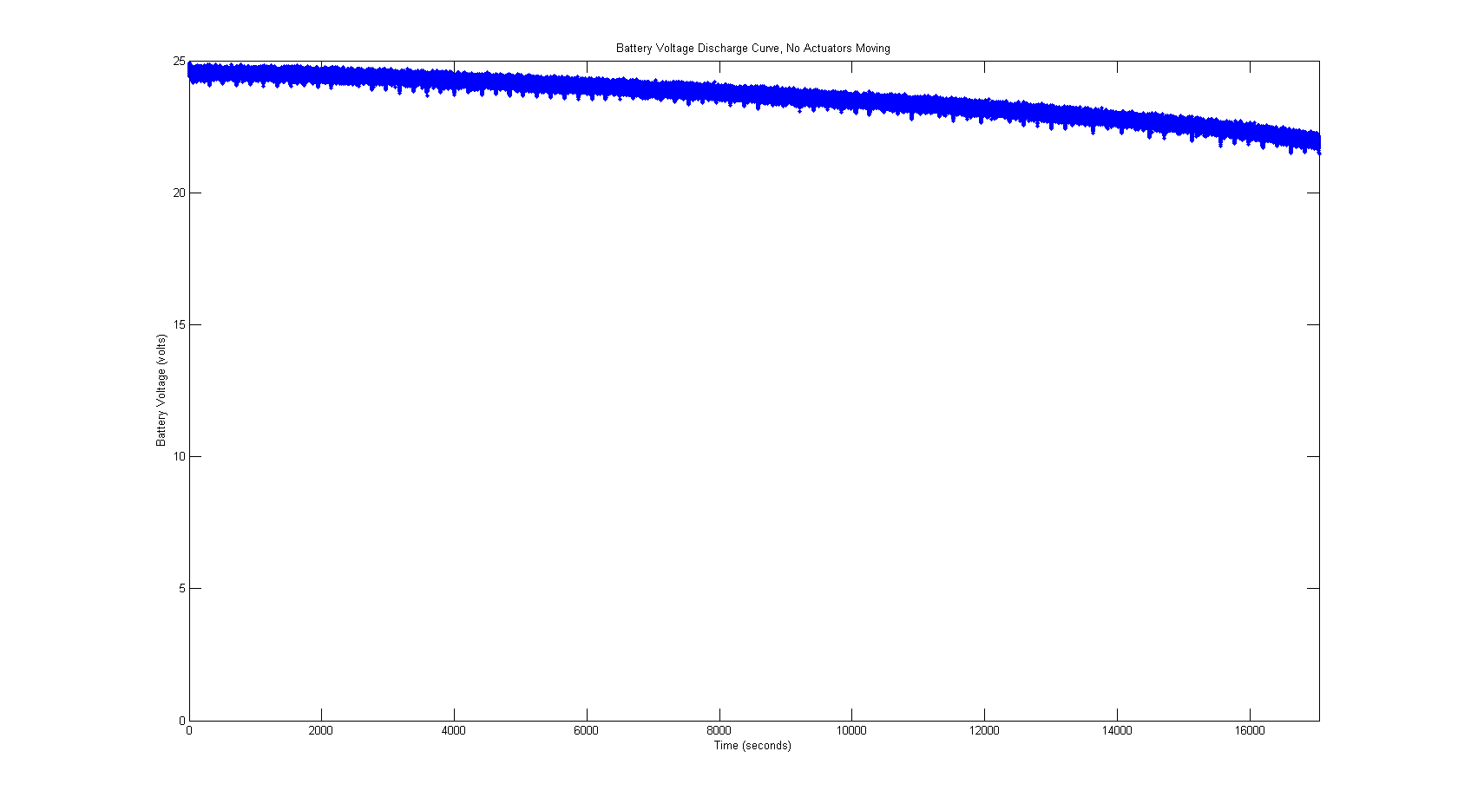

Figure 20: Voltage curve during discharge test with actuators idle.

In the first test, the robot’s systems are all turned on, but the actuators are disabled. In this idle test, the robot ran for 4 hours and 44 minutes before it hit the critical voltage.

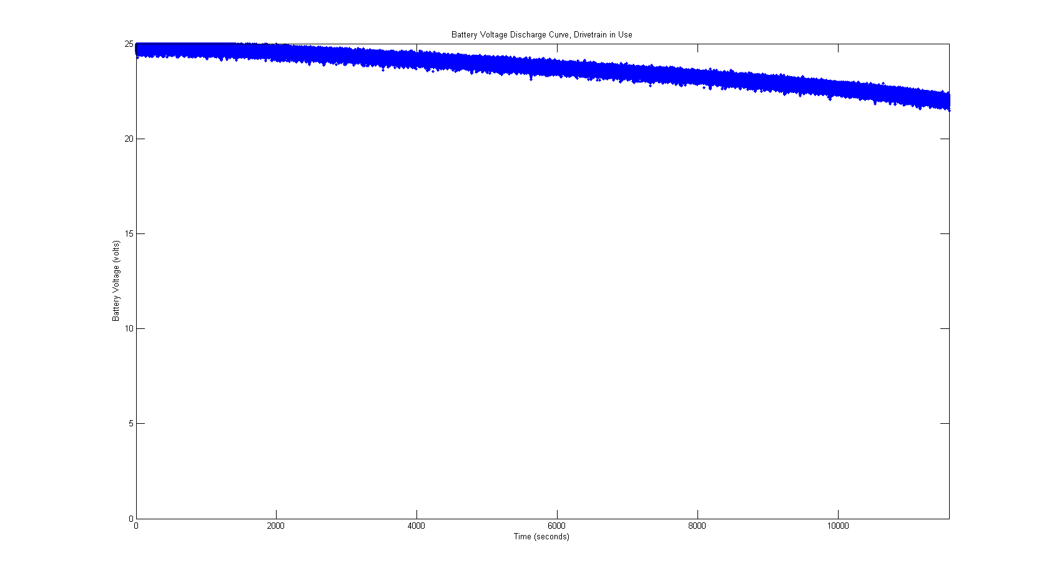

Figure 21: Voltage curve during discharge test with drivetrain exercised.

In the second test, the robot was strapped to a platform with rollers, and the drivetrain was exercised by commanding rotational velocities that followed a sawtooth profile, increasing from the maximum negative velocity to the maximum positive velocity, then resetting back to the maximum negative velocity. In this test, the robot ran for 3 hours and 13 minutes before it hit the critical voltage.

[ARM VOLTAGE FIGURE]

In the third test, the drivetrain was disabled but the arm was commanded to repeatedly execute trajectories between the stow position and the position to drop an object in the bin. At the end of each trajectory, the gripper was opened and closed. In this test, the robot ran for [RUNNING TIME].

From these tests, it appears likely that the robot could run in typical operation for about 3 [CHECK THIS] hours before its batteries are critically low. With adequate charging facilities and redundant robots or batteries, this should be adequate for a factory environment.

## The Kinect

### For Object Localization and Arm Planning

A major part of the validation task depended on the Kinect as a sensor for object segmentation and recognition. Unfortunately, the data from the Kinect proved to be unreliable.

### For Reading QR Codes

The Kinect’s RGB camera captures video at VGA resolution (640 by 480 pixels). Experiments with reading QR codes showed that a Kinect did not have sufficient resolution to read a tag, even when the tag filled the entire field of view of the Kinect. Unfortunately, this means that in order for the Kinect to be useful for recognition of tagged “smart” payloads, it must be paired with (and calibrated to) an external camera with a higher resolution sensor.

## Open Source Software

A major goal of this project was to use open source software, specifically software from the ROS community. The purpose of using open source software was to decrease development and testing time by leveraging the work of other researchers. In practice, this choice had mixed results.

The ROS core, consisting of the ROS graph node management and message passing systems, is stable and includes many tools that facilitate rapid robot development and management of complex robot software. However, much of the open source software developed for ROS is incomplete, limited, or inadequately tested. This section describes some of the problems encountered with open source software from the ROS community.

### API Stability

Much of the software created by the ROS community is still in progress, and so very few packages are guaranteed to be stable. Updates are frequent and usually provide improvements, but occasionally break existing functionality. This is especially true for distribution release updates, which frequently include API changes. ABBY is the first Case robot to use the Fuerte distribution of ROS, which was released in Spring 2012. At the time, Fuerte was the only ROS distribution to run on Ubuntu 12.04, which is the current Long Term Support release of Ubuntu. ROS Electric, the previous version of ROS, does not support Ubuntu 12.04. In order to port the existing CWRU ROS package to Fuerte, several changes had to be made. When the ROS Groovy distribution was released in Fall 2012, so many APIs were changed, particularly in the arm navigation stack, that the decision was made not to upgrade.

Another example of difficulties with unstable or unfinished ROS APIs is ROS Serial, a package that allows development of ROS nodes on microcontrollers. This package exposed an (undocumented) API for creating ROS services on microcontrollers, but the code was non-functional and clearly untested. As a result, ABBY uses a custom-written fork of ROS Serial that properly supports ROS services. The Groovy release of ROS serial includes a complete rewrite of the code in question, but the rewrite was not backported to ROS Fuerte.

### Documentation

ROS documentation is a mix of a wiki system, a question and answer forum, and autogenerated documentation of the code. Unfortunately, because the documentation is in the form of a wiki, it is often incomplete and out of date. The autogenerated documentation is up to date, but not often very helpful because the code itself is not annotated with comments. As a result, much of the autogenerated documentation is little more than a list of available methods and a link to the source code. The lack of documentation means that reading and understanding the source code is a must before using most ROS packages.

### Reusability of PR2 Software

The Willow Garage PR2 is a mobile manipulator with two arms and an array of sensors that is commonly used in robotics research. Because it is a common platform, and because it is the flagship product of Willow Garage, the maintainer of ROS, there is a lot of software available for the PR2. It was hoped that much of this software could be reused or adapted for ABBY, as it would open up a large library of abilities for ABBY. However, much of the software written for the PR2 is not written in such a way to be easily ported to other robots, and the documentation for PR2 software is often limited to instructions for running it on a PR2 or simulated PR2, meaning that even understanding what the software is doing and how to interface with it requires exploring the source code. As a result, the only PR2-specific software running on ABBY are the tabletop object segmentation node and the object bounding box server, which are a very small part of a tabletop object manipulation pipeline written for the PR2. The rest of ABBY’s software is either from more general ROS stacks or custom-written.

### Safety and Reliability

There are many standards and standard practices for writing software for industrial machines. These standards were created to ensure that the software runs safely and reliably, is robust, and fails gracefully and safely. ROS does not conform to these standards.

One example of ROS instability is the driver for the Kinect, which for several months had a bug that caused it to crash seemingly at random. Once the driver had crashed, it could only be restarted by killing the nonresponsive process and restarting it, sometimes several times. While this was simply a nuisance on a research robot, it would make the Kinect unusable with ROS in a production environment. The bug was eventually fixed, but the fact that it existed, unfixed, for so long is an example of how a lot of ROS code, even something as popular as the Kinect driver, is not yet ready for general use.

Other program instability was apparently in more concerning areas. The arm navigation stack includes several trajectory filters. Occasionally, one of the trajectory filters will fail. In this case, the safe behavior would be for it to emit an error and stop processing the trajectory or skip the filter. Instead, a malformed trajectory is passed to the next step in planning, which causes the entire arm controller to crash. This is not only wrong but potentially dangerous. Software running on a robot or industrial machine should never crash under any circumstances.

In fact, most ROS software will crash easily due to memory allocation errors when sent a malformed message. This behavior was observed in the inverse kinematics solver and in other ROS software. There is no ROS standard for checking whether memory has been allocated before accessing it, even for data structures from “untrusted” sources, such as messages received from other nodes. In addition to allowing for sloppy code to crash parts of the robot software, which is dangerous in and of itself, this exposes a large security hole in ROS. It is possible to bring down or otherwise compromise a robot simply by sending it a malformed message. Since message senders are not validated and messages are not encrypted in any way, an attacker could do this from anywhere on the robot’s subnet, provided the robot’s ROS master IP and port were known.

# Conclusions and Future Work

## Conclusions on ROS and Open Source Software

Although solving problems with open source software ended up taking up the majority of the time on this project, the ROS core enabled rapid development of the basic systems of the robot. In addition, ROS tools such as Rviz, rxconsole, and roslaunch enabled easy management and troubleshooting of the system. Independent development of similar GUI tools would have been a massive undertaking, beyond the scope of this project. Given the experiences described in this section, the best approach to open source software and ROS is to carefully choose which software packages to use and which to develop from scratch. If a mature, well-tested package exists for a specific task, it should be used. The ROS core, for instance, is well-tested and reliable, and it fulfills a specific purpose, i.e. management of a multiprocess robotic software system. On the other hand, the practice of adapting existing software for unintended purposes is not recommended, i.e. reusing code written for other robots or tasks, such as PR2 code. This also extends to software that has not been thoroughly tested. The ROS arm navigation stack is widely used, and there are many tutorials for using it with custom robots, but is listed on the ROS wiki as unstable. Although this did not initially cause concern, several bugs were encountered with the arm navigation code, as described above. Most of ROS is similarly a work in progress, and should be treated as such, even the components that have been “released.” Nothing outside of the ROS core should be considered safe for production use without rigorous independent testing.

## Future Work

This platform is nominally functional, but there is a lot of room for future work.

An IMU could have made significant improvements to the relative localization by helping to counteract errors due to wheel slip. Electrical problems with the yaw rate sensor made it unusable for this project, and the robot was not outfitted with accelerometers. However, the recent affordability of six degree of freedom single-chip IMUs would make this an excellent avenue of research to improve the localization system.

Similarly, optical flow sensors looking at the ground might be used to mitigate wheel slip error. Optical flow sensors bounce light off of a surface and measure how quickly that surface is moving relative to the sensor. A pair of optical flow sensors, mounted near the drive wheels, could supplement the odometry. Because they are unaffected by wheel slip, they might prove more accurate than the existing odometry system.

Another way to potentially improve the robot’s localization would be to use the Kinect. The Kinect’s limited range and field of view make it relatively useless for localization using building geometry such as AMCL or gmapping. However, because the Kinect is facing the floor, it could be used for absolute localization based on patterns on the floor. If the floor is marked with landmarks in the form of painted symbols or codes, the Kinect could be used to detect a landmark and localize the robot with respect to the known location of the landmark in the map. This technique has been used in other industrial mobile robots [4]. A system of visual landmarks on the floor might be useful as a starting seed pose for AMCL. Currently, when the robot is started, the starting pose must be manually entered using Rviz or a launch script. With visual landmarks on the floor, the robot could be started at any arbitrary point in the environment, provided a landmark was visible to the Kinect, and the robot could generate a starting pose estimate from the landmark.

As described above, the mobile base is not capable of precision navigation. There are a few ways to approach this problem. It may be possible to retune the existing PID controllers for more precise speed control. It would also be beneficial to replace the PID controllers with a different control system architecture, or at least PID controllers with feedforward. The cRIO currently used for the drive base control is expensive, cumbersome to program, and overpowered for the processing it performs. It would be useful to explore possible replacements for the cRIO, perhaps also offloading some of the processing duties onto more advanced motor controllers capable of internal PID control.

Although the problems with the low-level controllers on the robot are the main obstacle to more precise navigation, the higher level planners could also be improved. The local planner was originally designed for a holonomic drive base, and the global planner makes the assumption that the robot is approximately circular. This robot, which is effectively a long moment arm, violates the circular robot assumption.

In his masters thesis[11], Eric Perko addressed many of the problems with NavFn and base local planner and devised new algorithms for precision navigation of a mobile robot or wheelchair in an indoor environment. However, Perko's ROS implementations of his algorithms do not conform to the same API as existing ROS navigation nodes, nor do they provide the same functionality. Whereas the existing ROS navigation stack takes an arbitrary Pose (x, y, theta 2D coordinate) as a goal, Perko's path planner requires that all goals be predefined points in an *a priori* map. Furthermore, the path planner requires that path segments between the goals be predefined. In order to use this global planner in an industrial environment, every possible desired position in the inventory would have to be predefined, as well as a graph of paths between positions. This closely resembles the existing paradigm for AGV navigation. This set-up task would be monumental in a large factory, so Perko's global planner was not used for this project. Perko's local planner uses a combination of local path linearization and a third-order steering algorithm to generate velocity commands. Unlike base local planner, which takes in arbitrary paths composed of a series of poses, Perko's local planner requires that paths be defined as a series of line segments and constant-curvature arcs. This prevents it from being interoperable with NavFn. It would be useful to start examining other planning methods, perhaps building upon Eric Perko's work on precision navigation. Since most industrial environments are somewhat structured, it may be possible to use this structure to simplify the planning problem.

Additional future work involves improving the onboard sensor suite. Adding rear-facing sensors such as a second Kinect or a second LIDAR would allow the robot to safely back up, which it currently cannot do. A rear-facing LIDAR might also solve the problems that prevented the use of SLAM for absolute localization. In addition, it would further the affordability goal of the project to replace the current LIDAR with a cheaper model, but a cheaper laser ranging sensor may not be robust or accurate enough for this task.

One of the problems with the Kinect is that it is a low-resolution (VGA) camera. One of the key future goals of this project is to be able to identify manipulable objects from bar codes or QR codes on the objects themselves. Unfortunately, this is not possible using a Kinect. In order to do this, a higher resolution camera on the robot's manipulator could be used to examine objects to be picked up. Adding such a camera would open many avenues for research and software development; the robot will have to identify objects to examine and determine how to position the manipulator to examine the objects with its high resolution camera.

The two-position parallel plate gripper used for this project was simple and readily available, but it limits the robot to being able to manipulate boxes in a limited range of sizes. Replacing the gripper with a more dexterous hand would allow the robot to pick up a wider variety of objects and to grasp objects more securely.

A major undertaking would be to do a full stability analysis of all ROS software used on this robot. Over the course of the project, several problems were identified with ROS stability, a few of which are described above. For ROS software to be a viable option in an industrial environment, it must be meticulously tested and shown to be robust, secure, and safe. Currently, most software outside of the ROS core does not meet these requirements. Testing more ROS packages and improving their stability would be a boon to the open source robotics community and to the industrial robotics industry.

Before the robot can safely operate alongside humans, the safety features, both hardware and software, must be improved. As described above, the current emergency stop system is incomplete and relies on a tethered emergency stop button. The tether is inconvenient for testing and would be impossible to use in industry. The second iteration of the emergency stop, as described above, solves this problem and also adds several safety features, also described above. In addition to this hardware stop, the robot requires the reflexive stopping abilities described above. These safety features will be a necessary prerequisite for the robot to be usable in an industrial setting.

## Applications of this Robot

This robot was designed for experiments with kitting operations in a factory environment, but the platform is useful for other applications as well. Researchers at other institutions have used mobile manipulators for household tasks, and this platform could be used for similar research. This research could also dovetail into previous work at Case into assistive robots for the disabled.

This robot, with upgrades to its end effector, would also be an effective mobile manufacturing platform. Rather than having to build and rebuild a fixed manufacturing cell for each change in production requirements, industrial engineers could design rapidly reconfigurable assembly lines composed of one or more mobile manipulators. These systems would also allow rapid set-up of small manufacturing operations at new manufacturing sites and remote locations such as construction sites or in space.

## Conclusion

This thesis describes a mobile industrial manipulator designed and built from commercially available parts at minimal cost. Open source software was used to facilitate rapid implementation of advanced perception and motion planning capabilities. The capabilities of the off the shelf hardware and open source software were tested with a simple validation task, and recommendations were made for future work. Although this platform was designed specifically for kitting operations, other applications of the robot were discussed.

# Bibliography

[1] H. M. Barbera, J. P. C. Quinonero, M. A. Z. Izquierdo, and A. G. Skarmeta, “i-Fork: a flexible AGV system using topological and grid maps,” in *IEEE International Conference on Robotics and Automation (ICRA)*, 2003, vol. 2, pp. 2147–2152 vol.2.

[2] K. C. T. Vivaldini, J. P. M. Galdames, T. S. Bueno, R. C. Araújo, R. M. Sobral, M. Becker, and G. A. P. Caurin, “Robotic forklifts for intelligent warehouses: Routing, path planning, and auto-localization,” in *2010 IEEE International Conference on Industrial Technology (ICIT)*, 2010, pp. 1463–1468.

[3] G. Garibotto, S. Masciangelo, P. Bassino, C. Coelho, A. Pavan, and M. Marson, “Industrial exploitation of computer vision in logistic automation: autonomous control of an intelligent forklift truck,” in *1998 IEEE International Conference on Robotics and Automation*, 1998, vol. 2, pp. 1459–1464 vol.2.

[4] “Kiva vs. Automated Guided Vehicles.” [Online]. Available: http://www.kivasystems.com/solutions/kiva-vs-traditional/solutionskiva-vs-traditionalkiva-vs-agvs/. [Accessed: 22-Mar-2013].

[5] R. D’Andrea and P. Wurman, “Future challenges of coordinating hundreds of autonomous vehicles in distribution facilities,” in *IEEE International Conference on Technologies for Practical Robot Applications (TePRA)*, Nov., pp. 80–83.

[6] R. Bischoff, U. Huggenberger, and E. Prassler, “KUKA youBot - a mobile manipulator for research and education,” in *2011 IEEE International Conference on Robotics and Automation (ICRA)*, May, pp. 1–4.

[7] C. Cosma, M. Confente, M. Governo, and P. Fiorini, “An autonomous robot for indoor light logistics,” in *2004 IEEE/RSJ International Conference on Intelligent Robots and Systems, 2004. (IROS 2004). Proceedings*, Sept.-2 Oct., vol. 3, pp. 3003–3008 vol.3.

[8] A. Hermann, Z. Xue, S. W. Ruhl, and R. Dillmann, “Hardware and software architecture of a bimanual mobile manipulator for industrial application,” in *2011 IEEE International Conference on Robotics and Biomimetics (ROBIO)*, Dec., pp. 2282–2288.

[9] C. Rockey, E. Perko, and Ben Ballard, “HARLIE,” IGVC, May 2010.

[10] Samlex America, “DC-DC Step Down Converters Model SDC-15.” Samlex America.

[11] Eric Perko, “Precision Navigation for Indoor Mobile Robots,” Masters, Case Western Reserve University, Cleveland, OH, 2013.

[12] “ROS/Concepts - ROS Wiki.” [Online]. Available: http://www.ros.org/wiki/ROS/Concepts. [Accessed: 22-Mar-2013].

[13] “actionlib - ROS Wiki.” [Online]. Available: http://www.ros.org/wiki/actionlib. [Accessed: 22-Mar-2013].

[14] “openni\_kinect - ROS Wiki.” [Online]. Available: http://www.ros.org/wiki/openni\_kinect. [Accessed: 03-Apr-2013].

[15] “laser\_drivers - ROS Wiki.” [Online]. Available: http://www.ros.org/wiki/laser\_drivers?distro=fuerte. [Accessed: 03-Apr-2013].

[16] E. Venator, “Rosserial Service ‘Failed to parse subscriber’ - ROS Answers,” *ROS Answers*. [Online]. Available: http://answers.ros.org/question/48548/rosserial-service-failed-to-parse-subscriber/. [Accessed: 22-Mar-2013].

[17] E. Venator, “rosserial,” *GitHub*. [Online]. Available: https://github.com/evenator/rosserial. [Accessed: 22-Mar-2013].

[18] Shaun Edwards and Chris Lewis, “ROS-Industrial – Applying the Robot Operating System (ROS) to Industrial Applications,” presented at the ICRA ECHORD Workshop, St. Paul, Minnesota, USA, 2012.

[19] E. Venator, Gregory Lee, and W. Newman, “Hardware and Software Architecture of ABBY: An Industrial Mobile Manipulator,” presented at the IEEE International Conference on Automation Science and Engineering (Submitted), Madison, WI, USA, 2013.

[20] S. Thrun, W. Burgard, and D. Fox, *Probabilistic Robotics*. The MIT Press, 2005.

[21] Giorgio Grisetti, Cyrill Stachness, and Wolfram Burgard, “GMapping.” [Online]. Available: http://www.openslam.org/gmapping.html. [Accessed: 17-Feb-2013].

[22] Tony Yanick, Chase Nemeth, Beom Koh, and Avinash Karamchandani, “ALEN,” IGVC, 2009.

[23] “navfn - ROS Wiki.” [Online]. Available: http://www.ros.org/wiki/navfn. [Accessed: 13-Feb-2013].

[24] E. W. Dijkstra, “A note on two problems in connexion with graphs,” *Numer. Math.*, vol. 1, no. 1, pp. 269–271, Dec. 1959.

[25] “carrot\_planner - ROS Wiki.” [Online]. Available: http://www.ros.org/wiki/carrot\_planner. [Accessed: 22-Mar-2013].

[26] “Kinematic and Dynamic Solvers | The Orocos Project.” [Online]. Available: http://www.orocos.org/kdl/UserManual/kinematic\_solvers. [Accessed: 20-Mar-2013].

[27] “OpenRAVE | ikfast Module | OpenRAVE Documentation.” [Online]. Available: http://openrave.org/docs/latest\_stable/openravepy/ikfast/#ikfast-the-robot-kinematics-compiler. [Accessed: 20-Mar-2013].

[28] G. Sánchez and J.-C. Latombe, “A Single-Query Bi-Directional Probabilistic Roadmap Planner with Lazy Collision Checking,” in *Robotics Research*, P. R. A. Jarvis and P. A. Zelinsky, Eds. Springer Berlin Heidelberg, 2003, pp. 403–417.

[29] “tabletop\_object\_detector - ROS Wiki.” [Online]. Available: http://www.ros.org/wiki/tabletop\_object\_detector. [Accessed: 17-Feb-2013].

[30] M. A. Fischler and R. C. Bolles, “Random Sample Consensus: A Paradigm for Model Fitting with Applications to Image Analysis and Automated Cartography,” AI Center, SRI International, 333 Ravenswood Ave., Menlo Park, CA 94025, 213, Mar. 1980.

[31] “QR code,” *Wikipedia, the free encyclopedia*. 21-Mar-2013.

[32] Chad Rockey, “Low-Cost Sensor Package for Smart Wheelchair Obstacle Avoidance,” Masters, Case Western Reserve University, Cleveland, OH, 2012.

[33] rethink robotics, “baxter.” .

[34] W. Shackleford, R. Norcross, J. Marvel, and S. Szabo, “Integrating occlusion monitoring into human tracking for robot speed and separation monitoring,” in *Proceedings of the Workshop on Performance Metrics for Intelligent Systems*, New York, NY, USA, 2012, pp. 168–173.

# Appendix 1: Bill of Materials

|  |  |
| --- | --- |
| Item | Cost |
| Wheelchair Base | $3000 |
| Batteries | $400 |
| Chassis Frame Materials | $1000 |
| LIDAR | $6000 |
| IRB-120/IRC5 | $15000 |
| cRIO 9074  + 9403 DIO module  +9401 DIO module  + 9201 analog input module, | $4150 |
| PC | $550 |
| Kinect | $150 |
| Grayhill Encoder (4) | $320 |
| 13.8 v Regulator | $81 |
| I/O Breakout Board | $45 |
| Emergency Stop System | $160 |
| AC Inverter | $322 |
| Sabertooth 2x50 | $250 |
| Compressor | $250 |
| Network Equipment | $40 |
| RS-422 – USB converter | $80 |
| Arduino | $30 |
| Miscellaneous Electrical Components | $50 |
| **Total** | $31878.00 |

# Appendix 2: Localization Data

## Ten Meter Straight Line

|  |  |  |  |
| --- | --- | --- | --- |
| Trial | X | Y | Displacement |
| 1 | 9.535 | -2.908 | 9.969 |
| 2 | 10.042 | -0.760 | 10.071 |
| 3 | 10.373 | -0.032 | 10.373 |
| 4 | 9.995 | -0.454 | 10.005 |
| 5 | 9.881 | -0.663 | 9.903 |
| 6 | 10.018 | -0.609 | 10.036 |
| RMS | 9.974 | -0.904 | 10.059 |
| STD | 0.2711 | 1.015 | 0.1640 |

All measurements in meters, except where indicated. Perfect localization would be 10 meters translation in the x direction and 0 meters translation in the y direction.

## Five Laps of One Meter Radius Circle

|  |  |  |  |  |  |  |
| --- | --- | --- | --- | --- | --- | --- |
| Trial | x | y | Oz | Ow | Displacement | Heading (deg) |
| 1 | 0.730 | 0.432 | 0.507 | 0.862 | 0.849 | 29.124 |
| 2 | 0.802 | 0.450 | 0.528 | 0.849 | 0.920 | 26.202 |
| 3 | 0.941 | 0.596 | 0.613 | 0.790 | 1.114 | 14.370 |
| 4 | 0.751 | 0.621 | 0.558 | 0.830 | 0.974 | 22.150 |
| 5 | 0.778 | 0.330 | 0.459 | 0.889 | 0.845 | 35.404 |
| 6 | 0.892 | 0.434 | 0.502 | 0.865 | 0.992 | 29.677 |
| Average | 0.816 | 0.477 | 0.528 | 0.847 | 0.949 | 26.154 |
| Standard Deviation | 0.076 | 0.101 | 0.048 | 0.031 | 0.093 | 6.604 |

All measurements in meters, except where indicated. Oz and Ow indicate quaternion components z and w. Perfect localization would be 0 meters displacement and 0 degrees heading (the robot at the origin).